

MANIPAL SCHOOL OF INFORMATION SCIENCES
(A Constituent unit of MAHE, Manipal)
A PROJECT REPORT ON
AUTONOMOUS FIRMWARE FAULT LOCALIZATION
USING RUNTIME EXECUTION SIGNATURES
Reg. Number | Name | Branch
261100620002 | ABHAY KIRAN M | EMBEDDED SYSTEMS
261100620006 | ABHISHEK SATHYENDRAN | EMBEDDED SYSTEMS
261100620024 | ARFAN SAYYAD | EMBEDDED SYSTEMS

Under the guidance of
RAVIKALA KAMATH
Assistant Professor – Senior Scale,
Manipal School of Information Sciences,
MAHE, MANIPAL
November 2026

ACKNOWLEDGEMENTS

We take this opportunity to thank everyone who supported us while we carried out this project, "Autonomous Firmware Fault Localization using Runtime Execution Signatures".
We are sincerely grateful to our guide, Ms. Ravikala Kamath, Assistant Professor – Senior Scale, Manipal School of Information Sciences, for her guidance motivation and insightful suggestions throughout the preparation of this project.
We are also grateful to Dr. Keerthana Prasad, Professor and Director, Manipal School of Information Sciences, MAHE, Manipal, for her constant encouragement and for providing the necessary facilities in the institute.
We thank the faculty of the Manipal School of Information Sciences, MAHE, Manipal, for the laboratory facilities and for the coursework in embedded systems and real-time operating systems that gave us the background to attempt this work.
Finally, we would like to acknowledge the contributions of the authors of the published works cited in the references, whose research has been instrumental in shaping this study.

ABHAY KIRAN M
ABHISHEK SATHYENDRAN
ARFAN SAYYAD
ABSTRACT
Faults in embedded firmware are often difficult to identify because they do not always produce clear warning messages. Problems such as task failures, stack overflow, excessive interrupts, incorrect peripheral configurations, and memory access errors can cause unexpected system behaviour or complete system failure. Identifying these faults generally requires external debugging tools. This project presents an autonomous firmware fault localisation system that detects, identifies, and handles faults directly on the microcontroller without requiring external debugging equipment.
The proposed system was developed using an STM32 NUCLEO-F446RE board with an ARM Cortex-M4 processor operating at 84 MHz and running FreeRTOS. It monitors eight parameters: task execution sequence, interrupt timing, execution time, stack usage, peripheral configuration, watchdog events, memory access errors, and communication errors. The framework uses internal resources such as the DWT cycle counter, FreeRTOS trace hooks, an 8 KB RAM ring buffer, Memory Protection Unit (MPU), system fault registers, watchdog, and flash memory. Every 100 ms, execution data is compared with previously recorded normal behaviour. When an abnormal condition is detected, the system identifies the likely faulty component and assigns a confidence score between 30% and 99%. Recovery actions include restarting a task, reinitialising a peripheral, or resetting the microcontroller. A 164-byte fault report containing the last 16 execution events is stored in flash memory.
Testing was performed using a real-time sensor application consisting of a 1 kHz ADC data acquisition system with DMA, a four-stage processing pipeline running every 10 ms, and a telemetry task running every 100 ms. Ten fault types were introduced through a UART command interface, and 18 test cases were conducted. All 15 fault events were successfully detected, including register corruption and unexpected UART communication errors. Of these, 14 were correctly identified on the first attempt. Runtime faults were detected within 31–172 ms, with a median detection time of 72 ms, while memory protection faults were detected within 9–239 µs. No false alarms occurred during normal operation.
The framework introduced approximately 15 KB of RAM usage, along with an additional 8 KB trace buffer. Comparison of rule-based and statistical detection methods showed similar accuracy for actual faults, although the statistical method produced more false alarms during event-driven task execution.
The results demonstrate that embedded firmware faults can be detected, localised, and handled directly by the microcontroller, providing a lightweight solution for improving firmware reliability without external debugging equipment.

TABLE OF CONTENTS
CHAPTER 1 INTRODUCTION 1
1.1 PROBLEM STATEMENT 3
1.2 OBJECTIVES 3
1.3 SCOPE OF THE PROJECT 3
CHAPTER 2 LITERATURE REVIEW 4
2.1 COMPARISON OF RELATED WORK7
CHAPTER 3 SYSTEM REQUIREMENTS AND SPECIFICATIONS 8
3.1 FUNCTIONAL REQUIREMENTS 8
3.2 NON-FUNCTIONAL REQUIREMENTS 8
3.3 HARDWARE SPECIFICATIONS 8
3.4 SOFTWARE SPECIFICATIONS 9
3.5 SIGNALS TO BE OBSERVED 10
CHAPTER 4 SYSTEM ARCHITECTURE AND DESIGN 11
4.1 DESIGN OVERVIEW 11
4.2 SOFTWARE ARCHITECTURE 11
4.3 TASK AND INTERRUPT MODEL 13
4.4 SHARED INTERFACES 14
4.5 MEMORY LAYOUT 14
4.6 DESIGN DECISIONS 15
CHAPTER 5 THE MONITORED APPLICATION 17
5.1 PURPOSE OF THE APPLICATION 17
5.2 HARDWARE-TIMED ACQUISITION 17
5.3 THE SENSOR TASK 18
5.4 TELEMETRY AND INPUTS 18
5.5 COMMAND INTERFACE 18
CHAPTER 6 ON-CHIP CAPTURE USING CORTEX-M4 FEATURES 20
6.1 ARMV7-M DEBUG AND FAULT ARCHITECTURE 20
6.2 TIMESTAMPS FROM THE DWT CYCLE COUNTER 20
6.3 TRACE HOOKS 21
6.4 EVENT RING BUFFER 21
6.5 THE 100 MS SIGNATURE WINDOW 23
6.6 MEMORY PROTECTION UNIT 23
6.7 FAULT EXCEPTIONS AND THE TRAP PATH 24
6.8 RESET CAUSE AND RESET-SURVIVING RAM 25
6.9 PERIPHERAL AND COMMUNICATION ERRORS 25
CHAPTER 7 BASELINE LEARNING AND DETECTION 26
7.1 THE MONITOR TASK 26
7.2 BASELINE LEARNING 26
7.3 THRESHOLDS 27
7.4 DETECTION RULES 27
7.5 STATISTICAL LOCALIZER 28
CHAPTER 8 LOCALIZATION, CONFIDENCE AND RECOVERY 29
8.1 LOCALIZATION PIPELINE 29
8.2 CONFIDENCE SCORING 29
8.3 RECOVERY ENGINE 30
8.4 WATCHDOG DESIGN 31
8.5 FAULT REPORT AND FLASH BLACK BOX 31
CHAPTER 9 FAULT INJECTION FRAMEWORK 33
9.1 PROPOSED ARCHITECTURE 33
9.2 FAULT CATALOGUE 33
9.3 TASK FAULTS 34
9.4 HARDWARE FAULTS 35
CHAPTER 10 REAL-TIME CLOCK 36
10.1 DESIGN 36
CHAPTER 11 TESTING METHODOLOGY 38
11.1 PROCEDURE 38
11.2 TEST CASES 39
CHAPTER 12 RESULTS 41
12.1 TEST 1: BOOT AND SYSTEM HEALTH 41
12.2 TEST 2: BASELINE LEARNING 41
12.3 TEST 3: CLEAN RUN (FALSE-ALARM CHECK) 42
12.4 TEST 4: APPLICATION INPUT (PA0 AT GND AND 3.3 V) 43
12.5 TEST 5: STUCK TASK 44
12.6 TEST 6: ADC TRIGGER CORRUPTED 44
12.7 TEST 7: SAMPLING TIMER CORRUPTED 45
12.8 TEST 8: REGISTER WRITE WITHOUT THE INJECTOR 46
12.9 TEST 9: MISSED DEADLINE 46
12.10 TEST 10: WRONG EXECUTION SEQUENCE 47
12.11 TEST 11: INTERRUPT STORM 47
12.12 TEST 12: CORRUPTED COMMAND FRAME 48
12.13 TEST 13: WRITE TO PROTECTED MEMORY 48
12.14 TEST 14: STACK OVERFLOW 49
12.15 TEST 15: TOTAL HANG AND WATCHDOG RESET 50
12.16 TEST 16: RULE-BASED VS STATISTICAL LOCALIZER 50
12.17 TEST 17: CANCELLING A PENDING FAULT 51
12.18 TEST 18: FAULT LOG AFTER THE CAMPAIGN 52
12.19 IMPACT ON THE APPLICATION 52
12.20 SUMMARY OF MEASURED RESULTS 53
CHAPTER 13 DISCUSSION 54
13.1 ANSWER TO THE RESEARCH QUESTION 54
13.2 WHY HARD EVIDENCE MATTERS 54
13.3 TIMING EVIDENCE AND THE LOGARITHMIC SCORE 54
13.4 RULE-BASED VERSUS STATISTICAL 54
13.5 COMPARISON WITH OTHER APPROACHES 54
CHAPTER 14 CHALLENGES AND LIMITATIONS 56
14.1 ISSUES FACED AND HOW THEY WERE RESOLVED 56
14.2 LIMITATIONS 56
CHAPTER 15 CONCLUSION AND FUTURE SCOPE 58
15.1 CONCLUSION 58
15.2 FUTURE SCOPE 59
REFERENCES 61
LIST OF FIGURES
Figure 3.1: Hardware block diagram of the target setup 9
Figure 4.1: Three-stage approach: Capture, Compare, Localize and Recover 11
Figure 4.2: Layered software architecture and the hardware features it uses 12
Figure 4.3: Use of flash and SRAM, including the MPU-protected regions 15
Figure 5.1: Data path of the sensor application from the timer trigger to the alarm LED 17
Figure 6.1: Organisation of the event ring buffer 22
Figure 6.2: Construction of the signature vector in each 100 ms window 23
Figure 6.3: Hardware-stacked exception frame and the registers used to diagnose a fault 24
Figure 7.1: Life cycle of the monitor task 26
Figure 8.1: Localization pipeline from rule hits to the winning candidate 29
Figure 8.2: Confidence as a function of the margin (rule-based) and of S/T (statistical) 30
Figure 8.3: Escalation of recovery for repeated faults on the same component 31
Figure 9.1: Path of a fault from the command to the ground-truth record 33
Figure 10.1: Inputs and outputs of the real-time clock add-on 36
Figure 12.1: Serial output of Test 1 41
Figure 12.2: Serial output of Test 2 (a) 41
Figure 12.3: Serial output of Test 2 (b) 42
Figure 12.4: Serial output of Test 3 (a) 42
Figure 12.5: Serial output of Test 3 (b) 42
Figure 12.6: Serial output of Test 4 (a) 43
Figure 12.7: Serial output of Test 4 (b) 43
Figure 12.8: Serial output of Test 5 44
Figure 12.9: Serial output of Test 6 44
Figure 12.10: Serial output of Test 7 45
Figure 12.11: Serial output of Test 8 46
Figure 12.12: Serial output of Test 9 46
Figure 12.13: Serial output of Test 10 47
Figure 12.14: Serial output of Test 11 47
Figure 12.15: Serial output of Test 12 (a) 48
Figure 12.16: Serial output of Test 12 (b) 48
Figure 12.17: Serial output of Test 13 48
Figure 12.18: Serial output of Test 14 49
Figure 12.19: Serial output of Test 15 50
Figure 12.20: Serial output of Test 16 (a) 50
Figure 12.21: Serial output of Test 16 (b) 51
Figure 12.22: Serial output of Test 17 51
Figure 12.23: Serial output of Test 18 52
LIST OF TABLES
Table 2.1: Comparison of related work with this project 7
Table 3.1: Hardware used in the project 8
Table 3.2: Software tools and libraries 9
Table 3.3: The eight observed signals and how they are captured 10
Table 4.1: Tasks and interrupts of the system 13
Table 5.1: Command interface 18
Table 6.1: Debug and protection features of the Cortex-M4 and how they are used 20
Table 6.2: DWT registers used 21
Table 6.3: MPU regions used 23
Table 7.1: Detection thresholds 27
Table 7.2: Detection rules and their classes 28
Table 8.1: Confidence assigned to each type of evidence 30
Table 8.2: Recovery table 30
Table 8.3: Contents of a fault report 31
Table 9.1: Injectable faults 34
Table 11.1: Test cases of the campaign 39
Table 12.1: Key results of the test campaign 53
Table 14.1: Issues faced during the project and their resolution 56
ABBREVIATIONS
Abbreviation | Full form
ADC | Analog-to-Digital Converter
API | Application Programming Interface
ARM | Advanced RISC Machines
BFAR | BusFault Address Register
CFSR | Configurable Fault Status Register
CMSIS | Common Microcontroller Software Interface Standard
CPU | Central Processing Unit
CRC | Cyclic Redundancy Check
DEMCR | Debug Exception and Monitor Control Register
DMA | Direct Memory Access
DWT | Data Watchpoint and Trace unit
ETM | Embedded Trace Macrocell
EXC_RETURN | Exception return value held in LR on exception entry
FPB | Flash Patch and Breakpoint unit
FPU | Floating-Point Unit
GPIO | General-Purpose Input/Output
HAL | Hardware Abstraction Layer
HFSR | HardFault Status Register
IRQ | Interrupt Request
ISR | Interrupt Service Routine
ITM | Instrumentation Trace Macrocell
IWDG | Independent Watchdog
LED | Light-Emitting Diode
LSI | Low-Speed Internal oscillator
MCU | Microcontroller Unit
MMFAR | MemManage Fault Address Register
MPU | Memory Protection Unit
MSP | Main Stack Pointer
NVIC | Nested Vectored Interrupt Controller
PC | Program Counter
PRIMASK | Priority Mask register (global interrupt disable)
PSP | Process Stack Pointer
RAM | Random-Access Memory
RCC_CSR | Reset and Clock Control, Control/Status Register
RTOS | Real-Time Operating System
SCB | System Control Block
SRAM | Static Random-Access Memory
SWO | Serial Wire Output
TCB | Task Control Block
UART / USART | Universal (Synchronous/) Asynchronous Receiver/Transmitter
VCP | Virtual COM Port

CHAPTER 1
INTRODUCTION
Microcontrollers are widely used in modern electronic systems to perform monitoring, control, communication, and automation tasks. They are found in applications such as automotive electronics, industrial automation, medical equipment, robotics, power management systems, and smart devices. Most of these systems depend on embedded firmware to control hardware operations and ensure that tasks are executed within their specified time limits. As the complexity of embedded applications increases, ensuring the reliability and continuous operation of firmware becomes increasingly important.
Many modern embedded systems use a Real-Time Operating System (RTOS) to manage multiple tasks with different priorities and execution periods. These tasks communicate with hardware peripherals, process sensor data, control actuators, and handle communication protocols. Interrupt Service Routines (ISRs) are also used to respond to important hardware events. Since these operations are time-sensitive, even a small firmware error can affect task execution, interrupt handling, system timing, and overall performance. Such errors may eventually lead to unexpected behaviour, incorrect outputs, system instability, or complete system failure.
Traditional firmware debugging is generally performed using external debugging tools such as Serial Wire Debug (SWD), breakpoints, hardware trace units, and development environments. These tools are highly effective during development and testing because they allow engineers to examine program execution, inspect memory, monitor registers, and identify errors. However, these methods are not always practical once an embedded device is deployed in the field. Deployed systems may operate continuously for extended periods without direct human supervision or access to external debugging equipment. Consequently, identifying the cause of an unexpected failure becomes difficult, particularly when the fault occurs intermittently or cannot be reproduced under laboratory conditions.
To overcome these limitations, this project proposes a system for autonomous firmware fault localization using runtime execution signatures. The main objective is to develop an intelligent monitoring mechanism that continuously observes firmware execution, identifies abnormal behaviour, and estimates the location and severity of potential faults without requiring an external debugger or host computer.
The proposed approach is based on the concept of Runtime Execution Signatures. In a healthy embedded system, periodic tasks generally follow predictable execution patterns. Their execution time, activation frequency, processing sequence, and completion behaviour remain within an expected range under normal operating conditions. These characteristics can be collected during normal system operation and used to establish a reference execution signature for each task. During runtime, the actual execution behaviour is continuously compared with these reference signatures. Any significant deviation can indicate a possible firmware fault, abnormal execution condition, or timing violation.
The system uses the hardware monitoring capabilities available in ARM Cortex-M microcontrollers to collect execution-related information. The Data Watchpoint and Trace (DWT) unit provides a cycle counter that can be used to measure task execution time with high resolution. Runtime monitoring also considers task activation intervals, execution durations, missed deadlines, watchdog status, and other relevant execution events. These parameters are recorded using a lightweight event-monitoring mechanism designed to minimize the additional processing and memory overhead introduced by the monitoring system.
A lightweight fault-localization mechanism analyses the collected execution signatures to identify abnormal task behaviour. Based on the observed deviations, the system calculates a confidence score for each monitored task, represented as a percentage between 0 and 100. This score indicates the level of confidence that a particular task is associated with the detected abnormal behaviour. By evaluating multiple runtime parameters rather than depending on a single failure indicator, the system aims to provide more useful information about the possible source of a fault.
The proposed system is implemented on an STM32F446RE microcontroller using FreeRTOS. Multiple tasks with different priorities and execution periods are monitored continuously. A watchdog mechanism is incorporated to detect situations in which normal system execution cannot be maintained. Runtime events and diagnostic information are stored in a circular buffer, allowing recent execution history to be retained with limited memory usage. The collected information can also be transmitted through the ST-LINK Virtual COM Port for logging and analysis during development and validation.
An important feature of this project is its ability to perform monitoring and fault localization directly on the target microcontroller. Unlike conventional debugging approaches that depend on external tools or offline analysis, the proposed system performs execution monitoring and diagnostic evaluation during normal firmware operation. This makes the approach suitable for resource-constrained embedded applications where memory, processing power, and external debugging access are limited.
Overall, this project aims to improve embedded firmware dependability by introducing a continuous, lightweight, and autonomous runtime monitoring approach. By establishing normal execution signatures, detecting deviations, identifying potentially faulty tasks, and providing confidence-based diagnostic information, the proposed system helps reduce the difficulty of locating firmware faults in real-time embedded applications. It also provides a foundation for developing more reliable embedded systems capable of detecting and responding to abnormal execution behaviour with minimal human intervention.

1.1 PROBLEM STATEMENT
To develop a runtime framework for an ARM Cortex-M4 microcontroller running FreeRTOS that detects abnormal firmware execution and automatically identifies the most probable software or hardware component responsible, entirely on the chip and without a PC or external trace hardware during operation. The framework must observe the execution sequence, interrupt timing, task execution time, stack usage, peripheral status, watchdog events, memory-access anomalies and communication errors, and for every detected fault it must report the fault type, the suspected component, a confidence score, the relevant execution history and a recovery action. The research question is whether such lightweight execution signatures can provide useful fault localization without expensive external trace hardware.

1.2 OBJECTIVES
- Capture all eight runtime signals on the microcontroller with low overhead, using only on-chip debug, protection and timing features.
- Learn a baseline of normal behaviour on the board and store it persistently.
- Detect deviations from the baseline with rule-based checks running on the microcontroller.
- Localize each fault to a specific task, interrupt or peripheral and assign a confidence score.
- Recover automatically through a deterministic action and store a fault report for later retrieval.
- Evaluate detection, localization, false alarms, detection latency, CPU overhead and RAM overhead with deliberately injected faults.

1.3 SCOPE OF THE PROJECT
The project covers the complete chain from capture to report on a single STM32F446RE board. The monitored workload is a soft real-time sensor application written for this purpose, and a real-time clock add-on is used to quantify the effect of each fault on that application. Faults are injected deliberately through a command interface, so that every detection can be scored against a known ground truth.
Detection runs autonomously on the microcontroller. A PC is used only to read the UART output, type commands and store logs. Memory-protection faults are limited to stack overflow, writes to a read-only region and NULL-pointer accesses; full control-flow integrity is outside the scope. The statistical comparison is limited to a z-score localizer that runs on the board; offline machine-learning models are discussed only as future work. The evaluation consists of one to two trials per fault class on one board, which demonstrates the mechanisms but does not provide statistically strong detection rates.

CHAPTER 2
LITERATURE REVIEW
Avizienis, Laprie, Randell, and Landwehr established the fundamental concepts of dependable computing, explaining how faults can activate into errors, which may propagate through a system and eventually result in failures if no corrective action is taken [1]. Error detection and recovery mechanisms are essential for tolerating faults that cannot be completely eliminated during system development. For safety-related programmable electronic systems, IEC 61508 [2] and ISO 26262 [3] specify several runtime diagnostic techniques, including program sequence monitoring, independent watchdog timers, RAM and register testing, and memory protection. The proposed system incorporates several of these techniques, particularly an independent watchdog, stage-sequence monitoring, and register checksums. However, the implementation does not claim compliance with either standard.
Mahmood and McCluskey presented a survey of concurrent error detection techniques using watchdog processors, which monitor program execution by comparing the actual control flow with a predefined reference [9]. Oh, Shirvani and McCluskey proposed control-flow checking by software signatures, in which each basic block updates a run-time signature that is compared with an expected value [10]. The proposed system follows a similar approach through stage-transition monitoring. However, instead of monitoring individual basic blocks, the application identifies a limited number of processing stages. The permitted transitions between these stages are learned during normal execution rather than generated automatically by a compiler.
Wong et al. surveyed 331 research papers on software fault localization and classified existing techniques into six major categories: slice-based, spectrum-based, statistical, program-state-based, machine-learning-based, and model-based approaches [7]. Among these techniques, spectrum-based fault localization has received considerable attention. The Tarantula technique introduced by Jones, Harrold, and Stasko ranks program statements according to their execution frequency in successful and failing test cases [11]. Abreu, Zoeteweij, and van Gemund further investigated the accuracy of different similarity coefficients and demonstrated that the selection of a coefficient significantly influences fault-localization accuracy [12].
These conventional approaches generally require multiple test executions with known pass or fail outcomes and produce a ranked list of suspicious program statements for developer analysis. In contrast, the proposed system operates on a single continuously running embedded application without requiring a test oracle. It identifies the most likely faulty component and recommends an appropriate recovery action within a short execution time. The confidence score used in the proposed framework is similar to a suspiciousness score; however, it is calculated from deviations between observed runtime behaviour and previously learned normal operating ranges rather than pass/fail execution statistics.
Chang et al. introduced FirmRCA, a post-fuzzing root-cause analysis technique for ARM-based embedded firmware [8]. The technique reconstructs execution events from crashes discovered through fuzzing and performs event-based analysis to identify the root cause. Their evaluation considered 41 crashes across 17 firmware images and successfully localized the root cause within the top ten instructions for most of the evaluated crashes.
However, FirmRCA performs its analysis offline on a host system after a crash has been collected. It primarily targets security vulnerabilities identified through fuzzing rather than faults occurring during the normal operation of an embedded device.
Gabor investigated software fault injection and fault localization specifically for embedded systems [13]. The approach combines spectrum-based fault localization with assertions in C/C++ software and performs real-time, unsupervised experiments. The study demonstrated that embedded assertions can improve fault localization while also identifying potential biases in earlier fault-injection experiments. Nevertheless, the approach operates mainly at the software level and relies on a host system for analysis.
Yiu described the fault-exception mechanisms available in ARM Cortex-M3 and Cortex-M4 processors, including fault status registers and stacked exception frames, which can be used to identify the instruction responsible for a processor fault [5]. The ARMv7-M Architecture Reference Manual further specifies the behaviour and operation of these exception mechanisms and associated registers [4], [14].
The proposed framework utilizes these processor-level mechanisms to capture fault information directly from the firmware without requiring an external debugger. This allows the system to collect relevant fault details, including processor state and exception information, and use them during runtime fault localization.
Fault injection is an established approach for evaluating error-detection and fault-tolerance mechanisms because naturally occurring hardware and software faults may be too rare to provide sufficient experimental data. Hsueh, Tsai, and Iyer classified fault-injection techniques into four major categories: hardware-based, software-based, simulation-based, and hybrid approaches [15].
Software-implemented fault injection modifies memory locations, processor registers, or program execution during runtime. It is relatively inexpensive, repeatable, and portable, although its effectiveness is limited to faults that can be introduced through software. Ziade, Ayoubi, and Velazco reviewed different fault-injection tools and their supported fault models [16]. Similarly, Benso and Prinetto presented techniques and tools for evaluating the reliability of embedded systems [17].
The proposed framework employs software-based fault injection, where faults are introduced either within application tasks or through timer interrupts. The injected faults include infinite loops, unbounded recursion, illegal memory writes, disabled-interrupt conditions, and modifications to peripheral registers. This approach follows established fault-injection practices by reproducing fault effects similar to those caused by real software and hardware defects. Additionally, the framework maintains a ground-truth record of each injected fault and its occurrence time, allowing the detection and localization performance to be evaluated quantitatively.
Li, Makar, and Mitra proposed CASP (Concurrent Autonomous Chip Self-Test), a technique that performs processor hardware testing during normal operation using predefined test patterns stored in non-volatile memory [18]. CASP focuses primarily on detecting hardware defects within processors rather than identifying firmware-related faults. However, it shares an important concept with the proposed framework: autonomous online diagnosis with test results stored for subsequent analysis.
Chandola, Banerjee, and Kumar provided a comprehensive survey of anomaly-detection techniques, classifying them into statistical, classification-based, nearest-neighbour-based, and clustering-based approaches [19]. Statistical anomaly detection identifies observations that deviate significantly from the expected behaviour of a system. In particular, Gaussian-based statistical methods identify abnormal observations using deviations from the mean and standard deviation. This approach forms the basis of the statistical fault localizer implemented in the proposed framework.
Liu, Ting, and Zhou introduced the Isolation Forest algorithm, which identifies anomalies through random partitioning trees without requiring an explicit distance or density model [20]. Although this technique was considered as a possible offline comparison method, it was not implemented in the present project.
For efficient runtime statistical learning, Welford introduced a single-pass algorithm for calculating the running mean and variance [21]. This algorithm updates statistical values incrementally without requiring the storage of all previously collected samples. Its low memory requirements make it suitable for resource-constrained embedded systems. The proposed framework uses this approach to learn normal runtime behaviour and identify deviations without requiring large amounts of memory.
The reviewed literature demonstrates significant progress in dependable computing, runtime monitoring, software fault localization, hardware fault detection, and statistical anomaly detection. However, many existing approaches depend on offline analysis, external host systems, multiple test executions, or predefined execution models.

2.1 COMPARISON OF RELATED WORK
Table 2.1 compares the reviewed approaches with the framework developed in this project.
Table 2.1: Comparison of related work with this project
Work | Target | Where analysis runs | Output | Recovery
Wong et al. survey [7] | General software | Host, offline | Ranked suspicious statements | No
Jones et al., Tarantula [11] | Programs with test suites | Host, offline | Suspiciousness ranking | No
Chang et al., FirmRCA [8] | ARM firmware crashes from fuzzing | Host, offline | Root-cause instructions | No
Gabor [13] | Embedded C/C++ software | Host with injection | Localization with assertions | No
Li et al., CASP [18] | Processor hardware | On chip, on line | Pass/fail of self-test | Partial
Oh et al. [10] | Control flow | On chip | Control-flow error flag | No

CHAPTER 3
SYSTEM REQUIREMENTS AND SPECIFICATIONS

3.1 FUNCTIONAL REQUIREMENTS
- The system shall record task switches, interrupt entries and exits, application stage marks, peripheral errors and communication errors with cycle-accurate timestamps.
- The system shall build a signature of the system behaviour every 100 ms.
- The system shall learn a baseline from fault-free operation and keep it across resets.
- The system shall detect overruns, missed deadlines, abnormal interrupt rates, stack exhaustion, sequence violations, peripheral configuration changes, peripheral and communication errors, memory-protection violations and watchdog resets.
- For each fault the system shall report the fault type, suspected component, confidence, rules fired, program counter where available and the last 16 events.
- The system shall execute a recovery action from a fixed table and escalate if the same component fails again within 10 s.
- The system shall store each report in flash and list it on request.
- The system shall provide a command interface to inject faults, cancel them, read the ground-truth log, dump the trace and inspect the status.

3.2 NON-FUNCTIONAL REQUIREMENTS
- Detection, localization and recovery must work with no debugger or PC attached.
- Bounded memory: All buffers are statically sized; the monitor must fit beside the application in 128 KB of SRAM.
- Determinism: Recovery actions shall use predefined tables rather than adaptive decisions to ensure predictable system behaviour.
- Persistence: Fault reports and the execution baseline shall remain persistent across resets, watchdog resets, and firmware reflashing.
- Low false-alarm rate: Normal input variations and expected system operation shall not generate false fault alarms.

3.3 HARDWARE SPECIFICATIONS
Table 3.1: Hardware used in the project
Item | Specification | Use in the project
Development board | STM32 NUCLEO-F446RE | Complete target platform
Microcontroller | STM32F446RE, ARM Cortex-M4F, run at 84 MHz from the 16 MHz HSI through the PLL | Application and monitor
Memory | 512 KB Flash (8 sectors), 128 KB SRAM | Firmware, baseline (sector 6), reports (sector 7)
Debug and trace | DWT, ITM, FPB, MPU (8 regions), SCB fault registers | DWT, MPU and SCB used autonomously
Watchdog | Independent watchdog clocked by the 32 kHz LSI | Recovery from total hangs
Analog input | ADC1 channel 0 on PA0 (A0), 0–3.3 V | Sensor input of the application
Outputs | LD2 on PA5 (alarm), external LED with 330 Ω on PA6 / D12 (heartbeat) | Application output, liveness indicator
Host link | USART2 at 115200 baud through the ST- LINK virtual COM port | Command shell, reports, telemetry

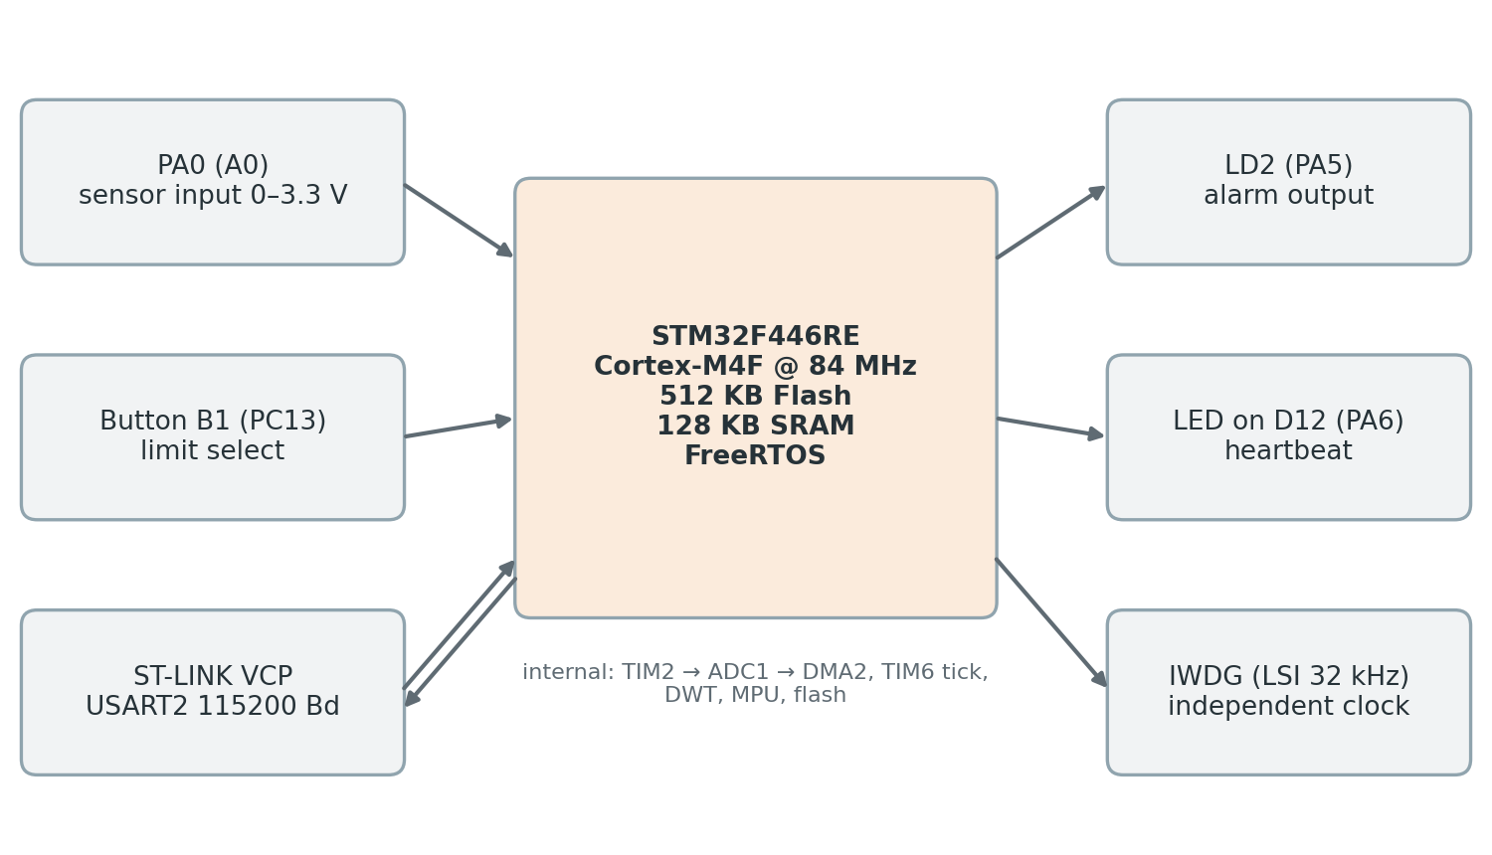
Figure 3.1: Hardware block diagram of the target setup

3.4 SOFTWARE SPECIFICATIONS

Table 3.2: Software tools and libraries
Item | Version / detail | Use
STM32CubeIDE | 1.19 with GNU Arm Embedded GCC | Editing, building, flashing
STM32CubeMX (integrated) | HAL drivers, clock and pin configuration | Board initialisation
FreeRTOS | Through the CMSIS-RTOS2 wrapper, preemptive, 1 kHz tick | Task scheduling
CMSIS-Core | Register definitions for DWT, MPU, SCB, NVIC | Low-level access
Serial terminal | PuTTY and Serial Debug Assistant, 115200 8-N-1 | Commands and log capture

3.5 SIGNALS TO BE OBSERVED
Table 3.3 shows how each of the eight signals is captured on the board and which rule uses it.

Table 3.3: The eight observed signals and how they are captured
Signal | Captured by | Used by rule
Function / task execution sequence | FreeRTOS switch hooks and application stage marks | Sequence, liveness
ISR timing | Enter and exit wrappers in each monitored ISR, DWT timestamps | ISR rate
Task execution time | DWT cycles between switch-in and switch-out | Overrun
Stack usage | Free-stack watermark and MPU guard regions | Stack, stack overflow
Peripheral status | CRC32 of configuration registers, error flags (ADC overrun, DMA error, timeout) | Peripheral
Watchdog events | Reset-cause register RCC_CSR at boot | Watchdog
Memory-access anomalies | MPU violations reported through MemManage and the CFSR | Trap
Communication errors | USART overrun, framing and noise flags, frame checksum | Communication

CHAPTER 4
SYSTEM ARCHITECTURE AND DESIGN

4.1 DESIGN OVERVIEW
The proposed framework operates using a three-stage approach, as shown in Figure 4.1.
In the first stage, the firmware runs normally while monitoring hooks collect runtime information. This includes task execution details, execution timing, stack usage, peripheral states, error flags, and the cause of the most recent system reset.
In the second stage, the collected information is processed at regular intervals of 100 ms to generate a runtime signature. This signature is compared with a baseline profile stored in flash memory to identify any deviations from normal system behaviour. If no abnormality is detected, the monitoring process continues without interrupting the normal operation of the firmware.
In the third stage, if an abnormality is detected, the framework identifies the potentially faulty component and assigns a confidence score indicating the likelihood of the detected fault. It then generates a diagnostic report containing the recent execution history and performs an appropriate recovery action to restore normal system operation.
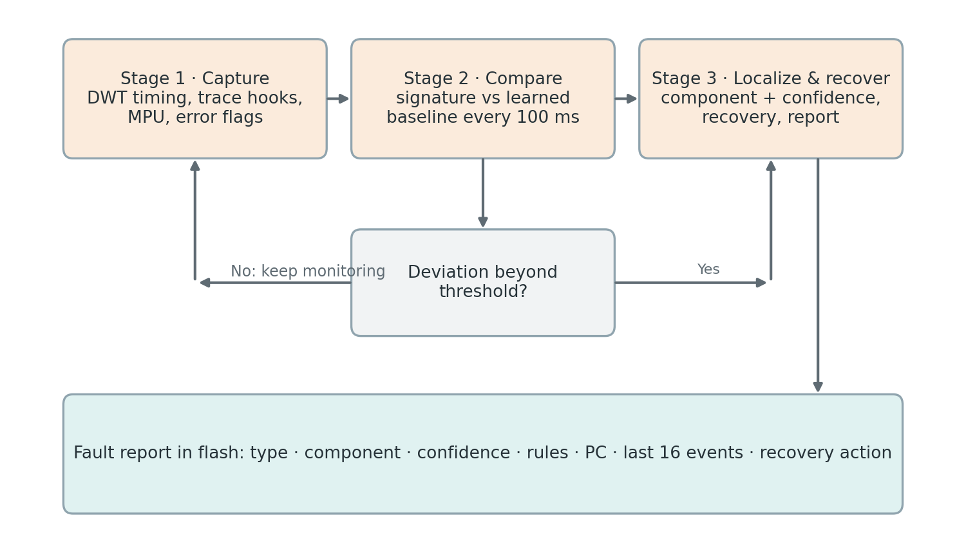
Figure 4.1: Three-stage approach: Capture, Compare, Localize and Recover

4.2 SOFTWARE ARCHITECTURE
The firmware is organised into four main layers, as illustrated in Figure 4.2.
The Application Layer contains the monitored sensor application and the real-time clock (RTC) add-on. It performs the normal application operations and provides the execution environment in which faults are monitored.
The Capture Layer is responsible for collecting runtime information without interfering with the normal execution of the application. Monitoring hooks record events in a ring buffer and update counters during each monitoring window. This information is later used by the detection mechanism.
The Detection Layer operates through a high-priority task. It learns the normal operating behaviour of the system, applies fault-detection rules, identifies potentially faulty components, and initiates the required recovery and reporting procedures.
The Injection and Shell Layer is mainly used for testing and demonstration purposes. It provides facilities to inject faults and interact with the framework through a command-line interface. This layer is not essential for the normal operation of the monitoring mechanism.
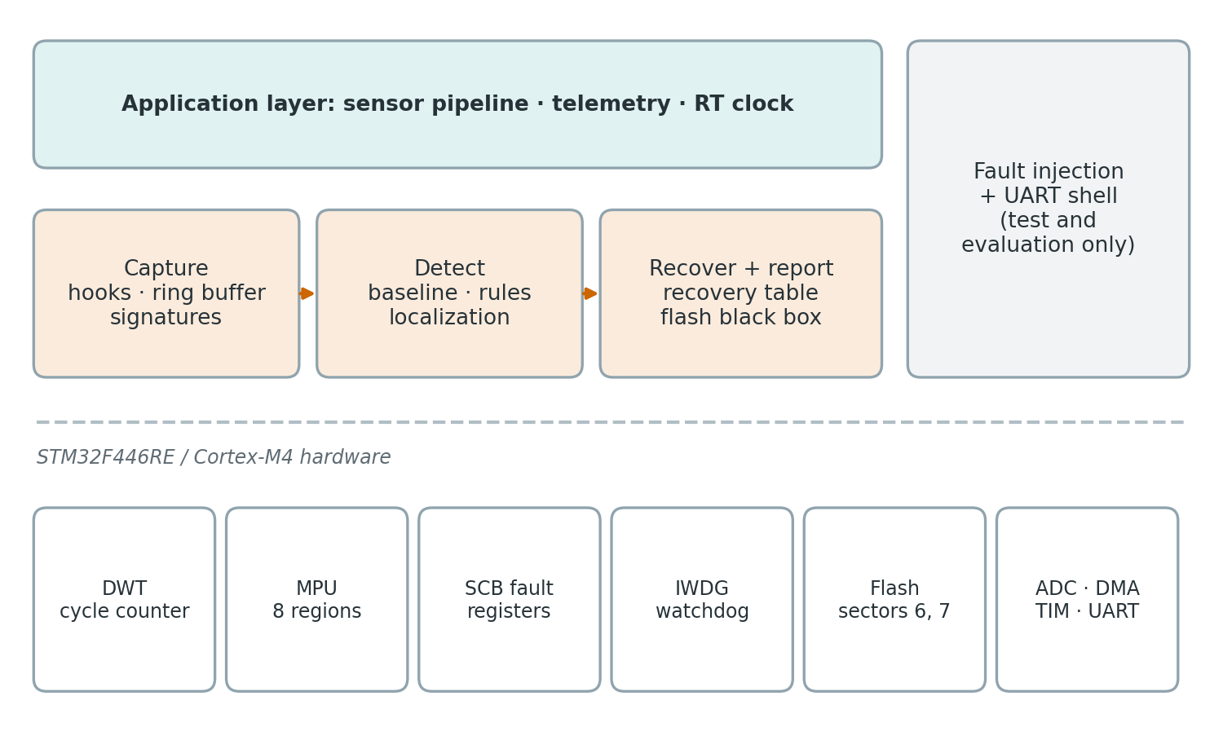
Figure 4.2: Layered software architecture and the hardware features it uses
Below these four layers, the hardware features shown in the lower section provide necessary processor and peripheral support for runtime monitoring, fault detection, and recovery.
The project source code is organised according to the four software layers. The /app directory contains the application-related code, while /monitor contains the runtime monitoring and data-capture implementation. The /detect directory includes the baseline learning, fault detection, fault localization, recovery, and black box reporting modules. The /inject directory contains the UART driver, command-line shell, and fault injection mechanisms used for testing and demonstration.
The Detection Layer is designed to operate independently of application-specific tasks and peripheral registers. Instead of directly accessing individual application components, the framework uses a component registration mechanism. During system initialization, each task, interrupt, and peripheral registers itself with the monitoring framework using a unique component identifier and name. This registration mechanism allows the framework to identify and monitor different system components without requiring prior knowledge of the application's internal implementation. As a result, the monitoring and fault-localization mechanism can be reused across different embedded applications with minimal modifications.

4.3 TASK AND INTERRUPT MODEL
The system runs on FreeRTOS with preemptive priority scheduling. Table 4.1 lists the tasks and interrupts and the reasoning behind their priorities.
Table 4.1: Tasks and interrupts of the system
ID | Component | Priority | Rate | Role
4 | wdg (watchdog feeder) | Realtime | 250 ms | Reloads the IWDG only if the monitor has checked in
3 | monitor | High | 100 ms | Signature, learning, detection, recovery
0 | sensor | AboveNormal | 10 ms | Application pipeline A → B → C → D
1 | report | Normal | 100 ms | Stage E: telemetry frame
– | rt_clock | BelowNormal | 10 ms | Real-time clock add-on (observer, not monitored)
2 | shell | Low | Polled, 100 ms | UART command interface
6 | tim6_isr | NVIC 5 | 1 kHz | Application tick, fires hardware faults
5 | adc_isr | NVIC 6 | 100 Hz | DMA block ready, wakes the sensor task
7 | uart_isr | NVIC 7 | on event | Receives and sends characters
8 | btn_isr | BSP default | on event | User button B1

The watchdog feeder task is assigned the highest priority to prevent it from being starved by other tasks. However, it reloads the hardware watchdog only when the monitoring task has recently reported its successful execution. This ensures that the watchdog is not refreshed if the monitoring mechanism itself becomes unresponsive.
The monitoring task is assigned a higher priority than all application tasks. This allows it to observe the system regularly, even if an application task enters an unexpected execution state or consumes excessive processor time.
The sensor task is given a higher priority than the reporting task because it has more time-critical operations and stricter execution deadlines. The shell and real-time clock (RTC) add-on tasks are assigned lower priorities so that their execution does not interfere with the main application or monitoring activities.
Regarding interrupt configuration, the Nested Vectored Interrupt Controller (NVIC) priority is configured to support FreeRTOS interrupt-safe API functions. With configMAX_SYSCALL_INTERRUPT_PRIORITY set to 5, interrupts with numerical priority values of 5 or greater (lower urgency) are permitted to call FreeRTOS FromISR functions. Interrupts with higher urgency (numerical priority values below 5) must not call these functions.

4.4 SHARED INTERFACES
Three data structures form the frozen interface between the layers. They were fixed before the layers were implemented and are checked at compile time.
The event record, event_t, is exactly 8 bytes: a 32-bit cycle timestamp from the DWT counter, an 8-bit component identifier, an 8-bit event type and a 16-bit extra field whose meaning depends on the type (stage number, interrupt duration in microseconds, fault status bits). Keeping the record small allows 1024 events in 8 KB.
The fault report, fault_report_t, is a fixed 164-byte record: a sequence number, the fault type, the suspected component, the confidence, the localizer that decided, the rules that fired, the recovery action, the program counter and fault status registers where available, the reset cause, timestamps and the last 16 events. A static assertion fixes its size because it is stored in flash and read back by later firmware versions.
The component identifiers form one shared enumeration: 0 sensor, 1 report, 2 shell, 3 monitor, 4 watchdog feeder, 5 ADC interrupt, 6 TIM6 interrupt, 7 UART interrupt, 8 button interrupt, 9 ADC1, 10 TIM2, 11 GPIOA and 12 USART2. Up to 16 components are supported.

4.5 MEMORY LAYOUT
Figure 4.3 shows how flash and SRAM are used. The linker script stops the firmware at the end of sector 5, so the baseline in sector 6 and the fault reports in sector 7 cannot be overwritten when the program grows, and they survive reflashing because the programmer only erases the sectors it writes. In SRAM, a .noinit section, which the start-up code does not clear, holds the crash record, the last execution history, the boot counter and the last injection. The MPU protects address zero against NULL-pointer accesses, makes a 32-byte configuration block read-only and places a 32-byte guard below the stack of each monitored task.
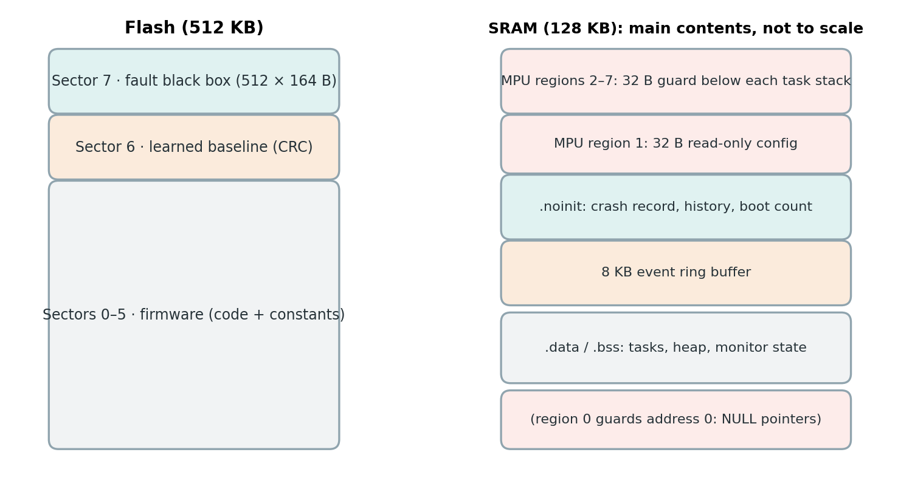
Figure 4.3: Use of flash and SRAM, including the MPU-protected regions

4.6 DESIGN DECISIONS
A monitoring window of 100 ms was selected to balance detection speed and processor usage. A shorter window can detect faults faster but requires more processing time and may collect fewer events for statistical analysis. A longer window reduces processing overhead but increases fault-detection time. Since the application has a task period of 10 ms, a 100 ms window contains ten complete sensor task cycles. This provides sufficient data for monitoring while keeping the monitor's CPU usage close to 1%.
The framework uses separate mechanisms for fault detection and event storage. Per-window counters are used for detection because they retain the collected counts throughout each monitoring window. A ring buffer stores recent events for diagnostic purposes and may overwrite older entries when it becomes full. Therefore, even if the ring buffer is full, fault detection continues without losing the counter information.
The baseline is learned directly on the STM32 board instead of being generated on a computer and programmed into the firmware. This ensures that the learned baseline represents the actual operating conditions of the device, including its firmware version, clock configuration, and interrupt activity. It also simplifies the development and testing process.
A fixed recovery mechanism was selected instead of an adaptive recovery system. Adaptive recovery may change its actions based on previous experiences, making its behaviour more difficult to predict and verify. In contrast, the proposed framework uses predefined recovery actions with an escalation mechanism. This makes the system behaviour predictable and easier to test under different fault conditions.
The monitoring task is assigned a higher priority than all application tasks so that it can continue monitoring even when an application task behaves unexpectedly. The watchdog feeder is assigned the highest priority and refreshes the hardware watchdog only after receiving confirmation that the monitoring task is functioning correctly. This arrangement ensures that a runaway application task cannot prevent fault detection and that a failure in the monitoring task can eventually lead to a system reset.

CHAPTER 5
THE MONITORED APPLICATION

5.1 PURPOSE OF THE APPLICATION
A practical application is needed to test the proposed fault-monitoring framework. For this purpose, a soft real-time sensor-monitoring application is used.
The application reads an input voltage, filters the sampled data, compares it with a predefined alarm limit, controls an alarm output, and sends telemetry data. Although the application is simple, it uses important embedded system features such as hardware timers, ADC, DMA, interrupts, multiple tasks with different priorities, and a communication interface. This makes it suitable for testing the monitoring framework under both normal and faulty operating conditions.
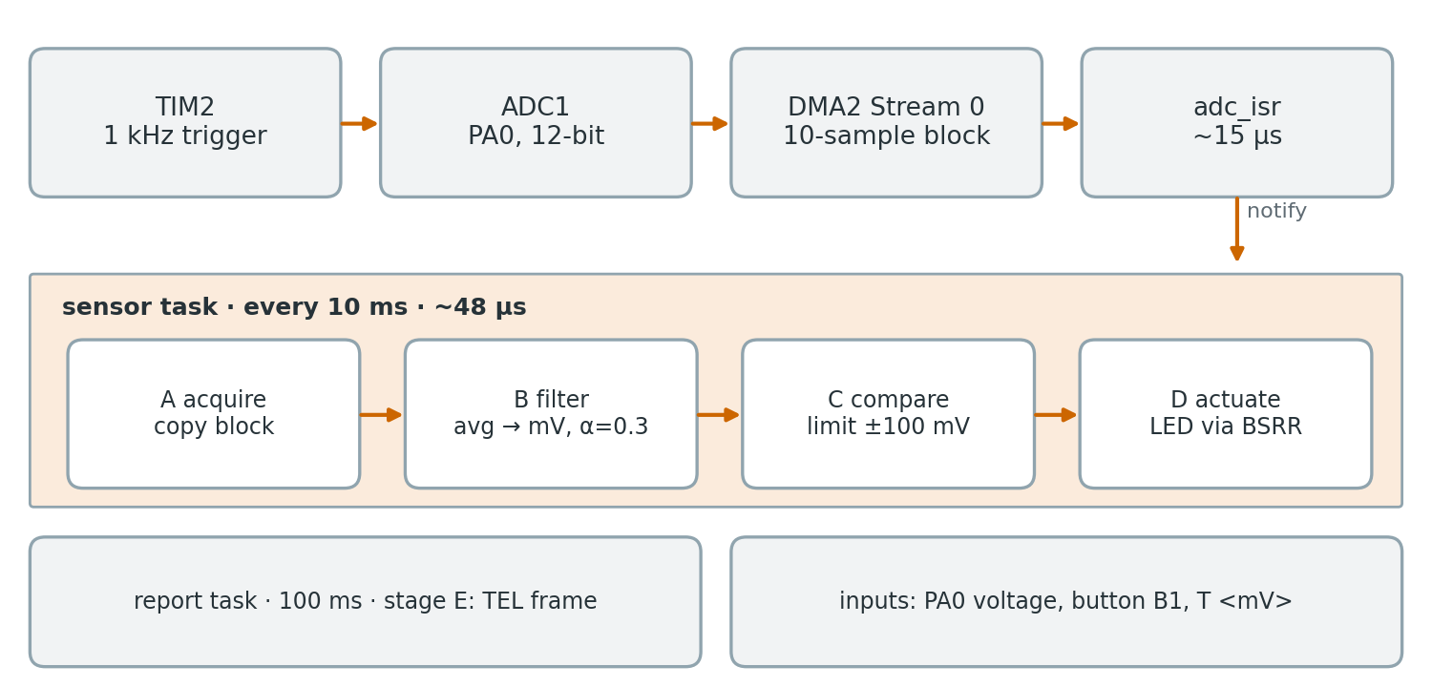
Figure 5.1: Data path of the sensor application from the timer trigger to the alarm LED

5.2 HARDWARE-TIMED ACQUISITION
TIM2 is configured to produce an update event at 1 kHz, and this event triggers one ADC1 conversion of channel 0 (PA0) in hardware, so the sampling rate does not depend on software timing. DMA2 Stream 0 moves each 12-bit result into a buffer of ten samples. When ten samples have been collected, every 10 ms, the DMA transfer-complete interrupt fires. The interrupt handler checks the DMA transfer-error and ADC overrun flags, copies the block, increments a block sequence counter and wakes the sensor task with a FreeRTOS task notification. Its measured execution time is about 15 µs.

5.3 THE SENSOR TASK
The sensor task waits for the notification with a 50 ms timeout. If no block arrives within that time, the sampling chain is broken and a timeout error is reported against ADC1. Otherwise the task runs four stages, each marked for the monitor:
- Stage A, Acquire: take the latest block of ten samples.
- Stage B, Filter: average the block, convert it to millivolts (× 3300 / 4095) and apply exponential smoothing with α = 0.3.
- Stage C, Compare: switch the alarm on above the limit (default 2000 mV) and off only below the limit minus 100 mV, so that the output does not flicker near the limit.
- Stage D, Actuate: write the alarm state to LED LD2 with a single write to the GPIO bit set/reset register.

5.4 TELEMETRY AND INPUTS

The report task runs every 100 ms and is marked as Stage E. It generates telemetry frames containing the frame number, timestamp, alarm limit, input voltage, and alarm status. An XOR checksum is added to each frame to detect communication errors. Only every tenth frame is printed, resulting in one telemetry message per second. The alarm limit can be changed using the user button, which cycles through 1000, 1650, 2000, and 2500 mV. It can also be changed using the T command through the UART interface.

5.5 COMMAND INTERFACE

The system uses single-letter commands through USART2 for user interaction. Each module registers its commands during system startup, allowing the shell to handle commands without depending on individual modules. Commands can also be sent in a framed format using $command*hh, where hh represents the XOR checksum. If the checksum does not match, the command is rejected and a communication error is reported.

The commands supported by the project are listed in Table 5.1.
Table 5.1: Command interface
Command | Function
H | List all commands
S | Live status: per-component signature, peripheral checksums, ring-buffer state, overhead line
V 1 / V 0 | Stream one signature line per window on or off
D | Dump the event ring buffer as CSV
L n | Learn the baseline from n windows (default 100)
B | Print the learned baseline
R / R n | List stored fault reports / show one report with its history
C | Clear the fault log in flash
M 0 / M 1 | Acting localizer: rule-based or statistical
K k | Detector sensitivity k (default 4)
I f c d | Arm fault f on component c after d ms
X | Cancel a pending fault
G | Print the ground-truth injection log
W a v | Write value v to address a (examiner tool)
T mV, Y 1/0 | Alarm limit; telemetry on/off
Z, Z R, Z 0/1 | Clock status; clock resync; clock line off/on

CHAPTER 6
ON-CHIP CAPTURE USING CORTEX-M4 FEATURES

6.1 ARMV7-M DEBUG AND FAULT ARCHITECTURE
The Cortex-M4 processor includes a built-in debug subsystem [4], [14]. Some of its features require an external debugging tool. For example, the Instrumentation Trace Macrocell (ITM) and Serial Wire Output (SWO) send debugging information through an output pin, while the Embedded Trace Macrocell (ETM) provides instruction-level execution trace. The Flash Patch and Breakpoint (FPB) unit is mainly used to set breakpoints during debugging.
In this project, only the features that can operate directly through firmware without an external debugger are used. The selected features are summarised in Table 6.1.
Table 6.1: Debug and protection features of the Cortex-M4 and how they are used
Feature | Normal purpose | Used here | Purpose in this project
DWT cycle counter | Profiling with a debugger | Yes | Timestamp of every event
CoreDebug DEMCR | Enable debug blocks | Yes | TRCENA bit powers the DWT
MPU | Memory isolation | Yes | NULL guard, read-only block, stack guards
SCB fault registers | Fault diagnosis | Yes | CFSR, HFSR, MMFAR, BFAR in crash records
DBGMCU (STM32) | Freeze peripherals while halted | Yes | IWDG stops when a debugger halts the core
ITM / SWO | printf-style trace to a host | No | Needs a probe and host
ETM | Instruction trace | No | Needs a trace port
FPB | Breakpoints | No | Debugger only

6.2 TIMESTAMPS FROM THE DWT CYCLE COUNTER
The Data Watchpoint and Trace (DWT) unit contains a 32-bit cycle counter called CYCCNT, which continuously counts CPU clock cycles. It is enabled by setting the TRCENA bit in the CoreDebug DEMCR register, followed by the CYCCNTENA bit in the DWT_CTRL register.
The counter can be read using a single instruction, making it suitable for recording timestamps during every task context switch. At a CPU frequency of 84 MHz, each count represents approximately 11.9 ns. Since it is a 32-bit counter, it wraps around after approximately 51.1 seconds.
To calculate time intervals, the framework uses unsigned subtraction. This method provides correct interval measurements even when the counter wraps around once between two readings.
Table 6.2: DWT registers used
Register | Address | Bit used
DEMCR | 0xE000EDFC | 24, TRCENA
DWT_CTRL | 0xE0001000 | 0, CYCCNTENA
DWT_CYCCNT | 0xE0001004 | 32-bit count

6.3 TRACE HOOKS
FreeRTOS provides two trace macros, traceTASK_SWITCHED_IN and traceTASK_SWITCHED_OUT, which are called during task context switching. In this project, these macros are connected to the framework's monitoring hook functions through FreeRTOSConfig.h [22].
Each monitored task is assigned a component identifier using the uxTaskNumber field in its Task Control Block (TCB). The identifier is stored as ID + 1, so that zero represents an unmonitored task. Interrupt handlers are monitored using FM_ISR_ENTER and FM_ISR_EXIT, while application stages are recorded using FM_STAGE.
Listing 6.1: Redirecting the kernel trace points
#define traceTASK_SWITCHED_IN() \
fm_hook_task_in(pxCurrentTCB->uxTaskNumber)
#define traceTASK_SWITCHED_OUT() \
fm_hook_task_out(pxCurrentTCB->uxTaskNumber)

Each monitoring hook performs two operations while briefly disabling interrupts. First, it records an event in the ring buffer. Second, it updates the current monitoring window counters for the corresponding component. These counters include the number of executions, total CPU cycles used, longest execution time, and longest interval between two executions.
High-frequency interrupts, such as the 1 kHz TIM6 interrupt and UART interrupt, are included in the monitoring statistics but excluded from the event history. This prevents frequent events from overwriting more useful diagnostic information in the ring buffer.

6.4 EVENT RING BUFFER
The framework uses a ring buffer to store recent runtime events. It can hold 1024 events, with each event occupying 8 bytes, giving a total storage size of 8 KB. The buffer is placed in the .noinit memory section so that recent event data remains available even after a watchdog reset. Since the buffer size is a power of two, a bitwise AND operation is used to update the buffer index instead of division. This reduces processing time during frequent operations such as task context switching. When the buffer becomes full, the oldest event is overwritten, and an overwrite counter is updated to track the number of lost events.
The push function saves the current PRIMASK value before disabling interrupts and restores the original value after completing the operation. This ensures that interrupts are not enabled unintentionally when the function is called during a FreeRTOS context switch.
Listing 6.2: Pushing an event into the ring buffer
void rb_push(ring_buffer_t *rb, const event_t *e)
{
uint32_t pm = __get_PRIMASK(); __disable_irq();
uint32_t next = (rb->head + 1U) & RB_MASK; // 1023
if (next == (rb->tail & RB_MASK)) { // full
rb->tail = (rb->tail + 1U) & RB_MASK; // drop oldest
rb->dropped++;
}
rb->buf[rb->head] = *e;
rb->head = next;
__set_PRIMASK(pm); // restore
}

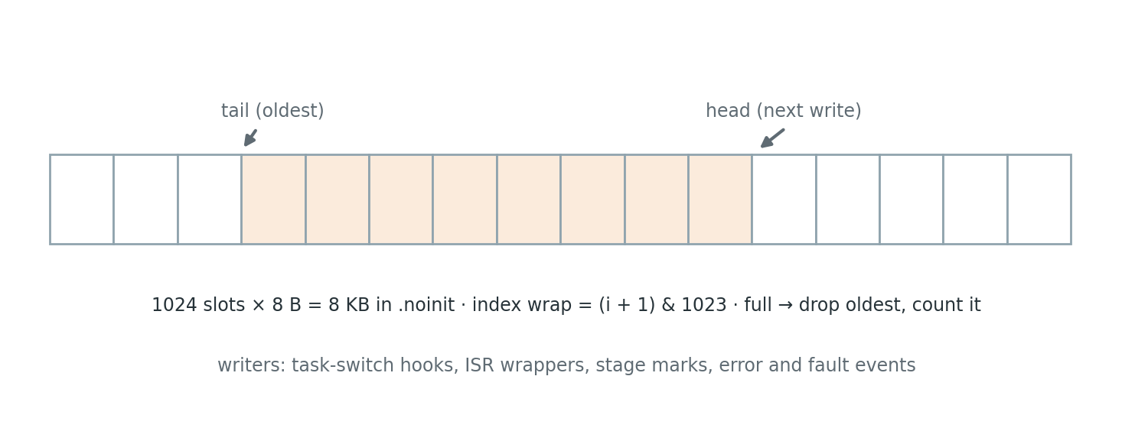
Figure 6.1: Organisation of the event ring buffer
The ring buffer has four main uses:
D command: Dumps the stored events in CSV format for analysis.
Fault report: Copies the latest 16 events into the fault report.
Fault handler: Saves the latest 16 events in .noinit memory before performing a reset.
Monitor: Saves an event snapshot into .noinit at the end of every monitoring window.
This helps preserve recent execution history during a watchdog reset, even when no fault handler gets a chance to execute.
The fault-detection mechanism does not directly use the ring buffer. Instead, it uses monitoring window counters because they require less processing time and do not lose information when the ring buffer overwrites old events.

6.5 THE 100 MS SIGNATURE WINDOW
Every 100 ms, the monitoring task collects the accumulated counters and combines them into a signature vector. After creating the signature, the counters are reset for the next monitoring window. For each component, the signature contains the number of executions, total CPU cycles, longest execution time, and longest interval between executions. If a component does not execute during a monitoring window, the time until the end of that window is considered its execution gap. This helps detect tasks that have stopped running unexpectedly.
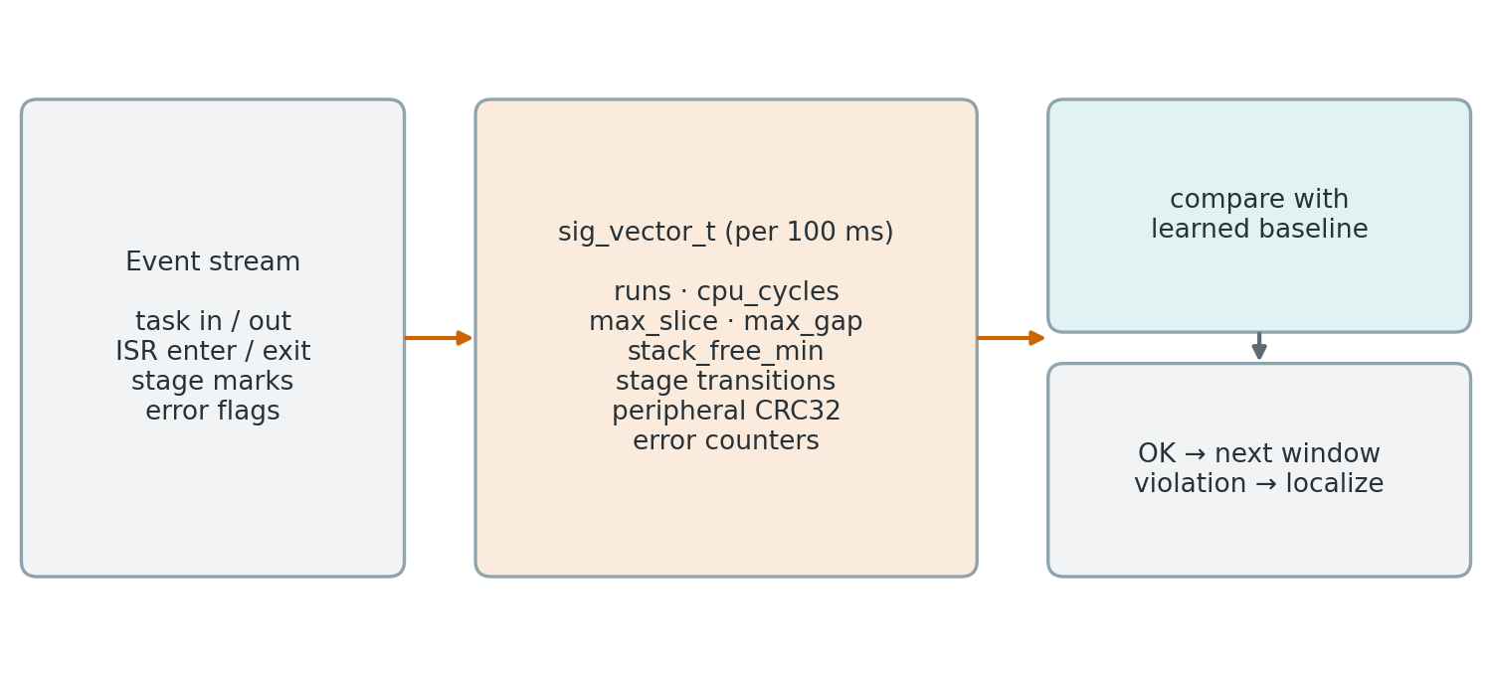
Figure 6.2: Construction of the signature vector in each 100 ms window
The signature vector also includes the remaining stack space of each task, stage-transition counts, CRC32 checksums of peripheral configuration registers, and error counters. Only the important bits of the peripheral registers are included in the checksum calculation. During normal operation, the sensor task executes 10 times within a 100 ms window, and the ADC interrupt also occurs 10 times. The TIM6 interrupt executes approximately 100 times, while the report task executes once. The stage transitions A→B, B→C, C→D, and D→A each occur 10 times.
These regular execution patterns represent the normal behaviour of the application and are used to create a baseline signature for detecting abnormal conditions.

6.6 MEMORY PROTECTION UNIT
The MPU checks every load and store in hardware at no run-time cost. Its regions must be a power of two in size and aligned to their size, which is why the protected configuration block is exactly 32 bytes and 32-byte aligned. The PRIVDEFENA bit keeps the default memory map for all addresses not covered by a region, so only the protected regions change behaviour.

Table 6.3: MPU regions used
Region | Covers | Size | Access | Catches
0 | Address 0x0000_0000 | 1 KB | None | NULL-pointer access
1 | Application configuration block | 32 B | Read-only | Stray writes to settings
2–7 | Bottom of each monitored task stack | 32 B | None | Stack overflow

The stack guards make stack-overflow detection immediate. A stack grows downwards, and without protection an overflowing task silently overwrites whatever lies below its stack. With a no-access guard there, the first write into the guard raises a MemManage fault before any neighbouring memory is touched. FreeRTOS's own stack check (configCHECK_FOR_STACK_OVERFLOW = 2) is kept as a second line of defence.

6.7 FAULT EXCEPTIONS AND THE TRAP PATH
The MemManage, BusFault and UsageFault exceptions are enabled separately in the SHCSR register, and divide-by-zero is made to trap through CCR.DIV_0_TRP. On a fault the core pushes eight registers onto the active stack (Figure 6.3) and loads a special EXC_RETURN value into LR. Bit 2 of EXC_RETURN tells whether the process stack was in use, which means that a task was running. The stacked PC at offset 24 is the exact faulting instruction. The configurable fault status register CFSR tells what went wrong: its low byte is the MemManage status, with DACCVIOL (bit 1) for a data access violation and MMARVALID (bit 7) when MMFAR holds the faulting address [5].
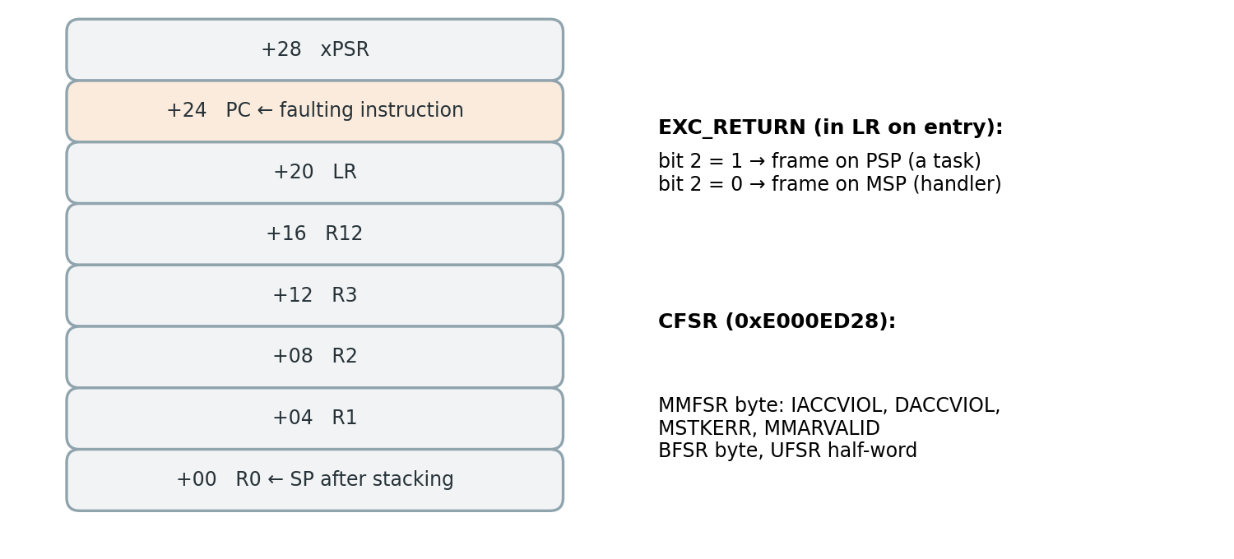
Figure 6.3: Hardware-stacked exception frame and the registers used to diagnose a fault
The handlers themselves are short: they read LR and call fm_trap. This function reads CFSR and the fault address, selects the correct stack from EXC_RETURN, takes the stacked PC unless the fault happened during stacking, classifies the fault as a stack overflow if the address lies inside a stack guard and as a memory-access fault otherwise, copies the last 16 events into .noinit and resets the chip. After the reboot, the monitor turns this record into a normal fault report.
Listing 6.3: Fault handler and trap path (condensed)
void MemManage_Handler(void) {
uint32_t exc_return;
__asm volatile ("mov %0, lr" : "=r"(exc_return));
fm_trap(FM_TRAP_MEMMANAGE, exc_return);
}
void fm_trap(uint8_t kind, uint32_t exc_return) {
uint32_t cfsr = SCB->CFSR, addr = 0;
if (cfsr & SCB_CFSR_MMARVALID_Msk) addr = SCB->MMFAR;
if ((exc_return & 0x4) && !(cfsr & STACKING_ERR)) {
const uint32_t *f = (const uint32_t *)__get_PSP();
pc = f[6]; // stacked PC
}
type = in_stack_guard(addr) ? STACK_OVERFLOW : MEM_ACCESS;
save_crash_record(); // .noinit + 16 events
NVIC_SystemReset();
}

6.8 RESET CAUSE AND RESET-SURVIVING RAM
After every reset, the firmware first reads the RCC_CSR register to identify the reset cause. It checks whether the reset occurred due to power-on, an external reset pin, a software reset, or the independent watchdog [6]. The flags are then cleared.
During a power-on reset, the .noinit memory area is cleared. For other types of reset, its contents are checked and preserved. This memory area stores the crash record, the latest 16 events, boot counter, last running component, and most recent fault-injection record. Before starting the scheduler, the firmware also saves the identifier of the last running component. This information is later used by the watchdog to generate a fault report.

6.9 PERIPHERAL AND COMMUNICATION ERRORS
Each registered peripheral provides a list of configuration registers and their corresponding bit masks. These include ADC1 trigger settings, TIM2 prescaler, PA0 and PA5 GPIO configurations, and USART2 sampling settings. The monitoring framework calculates a CRC32 checksum of these selected register values during every monitoring window and compares it with the baseline value. Any mismatch indicates a possible change in peripheral configuration.
The framework also monitors different error conditions. The ADC interrupt reports DMA transfer errors and ADC overruns, while the sensor task reports sampling timeouts. The UART driver detects overrun, framing, and noise errors, along with telemetry frame checksum mismatches.

CHAPTER 7
BASELINE LEARNING AND DETECTION

7.1 THE MONITOR TASK
The monitor is a high-priority FreeRTOS task that executes every 100 ms using osDelayUntil. This maintains a fixed monitoring interval without timing drift. During each cycle, the monitor collects the signature data, records the available stack space, checks in with the watchdog feeder, and processes pending shell commands such as baseline learning and log clearing.
As shown in Figure 7.1, the monitor initially ignores the first ten windows because the system may not be stable during startup. If a valid baseline is available in flash memory, it directly enters the monitoring mode. Otherwise, it starts the baseline learning process. After performing a recovery action, the monitor ignores the next three windows to allow the system to return to normal operation.
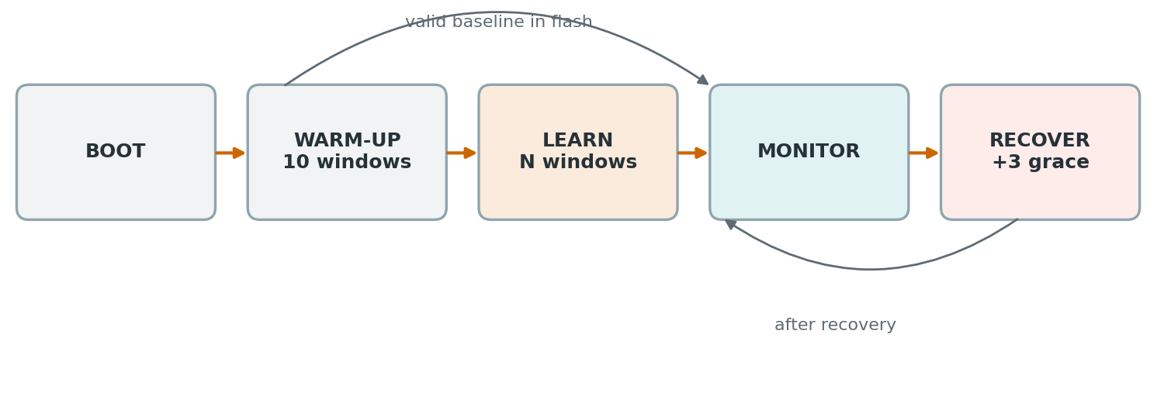
Figure 7.1: Life cycle of the monitor task

7.2 BASELINE LEARNING
Storing all runtime signatures in SRAM requires a large amount of memory. To overcome this limitation, the framework uses Welford's online algorithm [21]. It calculates the running mean and standard deviation without storing all previous samples, making it suitable for resource-constrained embedded systems.
For each component, the baseline stores the mean, standard deviation, and maximum values of the execution count, CPU cycles, and longest execution time. It also records the longest execution gap, minimum available stack space, and whether the component follows a periodic execution pattern. The baseline also stores the observed stage transitions, peripheral configuration CRC values, and a fingerprint of the registered components. Once learning is completed, the baseline is saved in flash memory sector 6 along with a CRC32 checksum. If the registered component set changes, the existing baseline is automatically rejected.
Listing 7.1: Welford update used during learning
void fm_welford_add(fm_welford_t *w, float x)
{
w->n++;
float d = x - w->mean;
w->mean += d / (float)w->n;
w->m2 += d * (x - w->mean);
}
// standard deviation = sqrt(m2 / (n - 1))

Learning runs for 100 windows (10 s) by default. Faults must not be injected while learning, or the faulty behaviour becomes part of "normal".

7.3 THRESHOLDS
The framework uses different thresholds to identify abnormal behaviour. Each threshold is calculated using the mean, standard deviation, maximum observed value, and a minimum fixed limit. This ensures that the threshold considers both normal variations and previously observed maximum values. The default sensitivity value is set to 4 and can be changed using the K command. During detection, the measured value is divided by its threshold to calculate a margin. If the margin is greater than 1, the corresponding component is considered abnormal. A higher margin indicates a greater deviation from normal behaviour.
Table 7.1: Detection thresholds
Feature | Threshold (largest term applies) | Applies to
CPU time per window | max(μ + kσ, 1.5 × max, 5 % of the window) | Periodic tasks
Longest single run | max(μ + kσ, 2 × max, 1 ms) | Periodic tasks
Event-driven task | max(50 % of the window, 1.5 × max) | Irregular tasks
Interrupt rate | max(μ + kσ, 1.5 × max) + 2 | Periodic interrupts
Liveness | 2 × longest gap seen + 2 ms | Periodic, regular components
Stack | free < 16 words and below baseline | Tasks

For example, the sensor task normally executes every 10 ms. Its liveness threshold is calculated as 22 ms (2 × 10 + 2). If the task remains inactive for 100 ms, the resulting margin is approximately 4.5, indicating a significant deviation from normal execution.

7.4 DETECTION RULES
The framework uses two types of detection rules: timing-based rules and hard-evidence rules, as shown in Table 7.2. Timing-based rules identify abnormal execution patterns by comparing runtime measurements with the learned thresholds. Hard-evidence rules identify faults using direct indications such as unexpected stage transitions, peripheral configuration changes, error flags, and processor faults.
Hard evidence is given higher priority than timing-based evidence because timing abnormalities may occur as a result of another underlying fault. For example, if the ADC stops working, the sensor task may remain inactive while waiting for new samples. In this case, the actual fault is associated with the ADC rather than the sensor task.
Table 7.2: Detection rules and their classes
Bit | Rule | Class | Typical fault
0x0001 | OVERRUN | Timing | Task running far too long
0x0002 | LIVENESS | Timing | Task or ISR silent too long
0x0004 | ISR_RATE | Timing | Interrupt storm
0x0008 | STACK | Hard | Stack nearly exhausted
0x0010 | SEQUENCE | Hard | Stage transition never seen in learning
0x0020 | PERIPH_CFG | Hard | Configuration register changed
0x0040 | PERIPH_ERR | Hard | ADC overrun, DMA error, sampling timeout
0x0080 | COMM | Hard | UART error flag or frame checksum
0x0100 | TRAP | Hard, after reset | MemManage, BusFault, UsageFault
0x0200 | WATCHDOG | Hard, after reset | Independent watchdog reset
0x0400 | STAT | Statistical | Sum of squared z-scores above threshold

7.5 STATISTICAL LOCALIZER
The statistical localizer uses a separate method from the rule-based localizer. For every task and interrupt, it calculates a z-score for four runtime features: execution count, CPU time, longest execution time, and longest execution gap.
A minimum standard deviation is used in the calculation to prevent very small variations from producing extremely large z-scores. The squared z-scores of all four features are then added to calculate the total anomaly score (S), as shown in Equations (7.1) and (7.2).
The calculated score is compared with a threshold (T), which is set to 128 for the default sensitivity value of k = 4. If S exceeds T, the component is identified as a potential fault candidate. The component with the highest score is selected as the most likely faulty component.
z_f = (x_f − μ_f) / max(σ_f, 0.05·μ_f, 1)(7.1)
S = Σ z_f² (over runs, CPU time, longest run, gap)(7.2)
T = 2 · (2k)² = 128 for k = 4(7.3)
Both the rule-based and statistical localizers execute during every monitoring window. The M command allows the user to select which localizer controls the final decision. The other localizer continues running in the background and prints its result as a !SHADOW message. This allows both methods to be compared using the same runtime data.

CHAPTER 8
LOCALIZATION, CONFIDENCE AND RECOVERY

8.1 LOCALIZATION PIPELINE
Each component that violates a detection rule is identified as a candidate with a fault type and a corresponding margin. These candidates pass through four filtering stages, as shown in Figure 8.1. First, hard evidence is given priority, and timing-based candidates that are only symptoms of another fault are removed. Next, the debounce mechanism checks whether a timing violation continues for two consecutive monitoring windows, unless its margin is 3 or higher. The victim suppression mechanism removes lower-priority tasks that become inactive because a higher-priority task is consuming the CPU. Finally, the candidate with the highest margin is selected as the most likely faulty component.
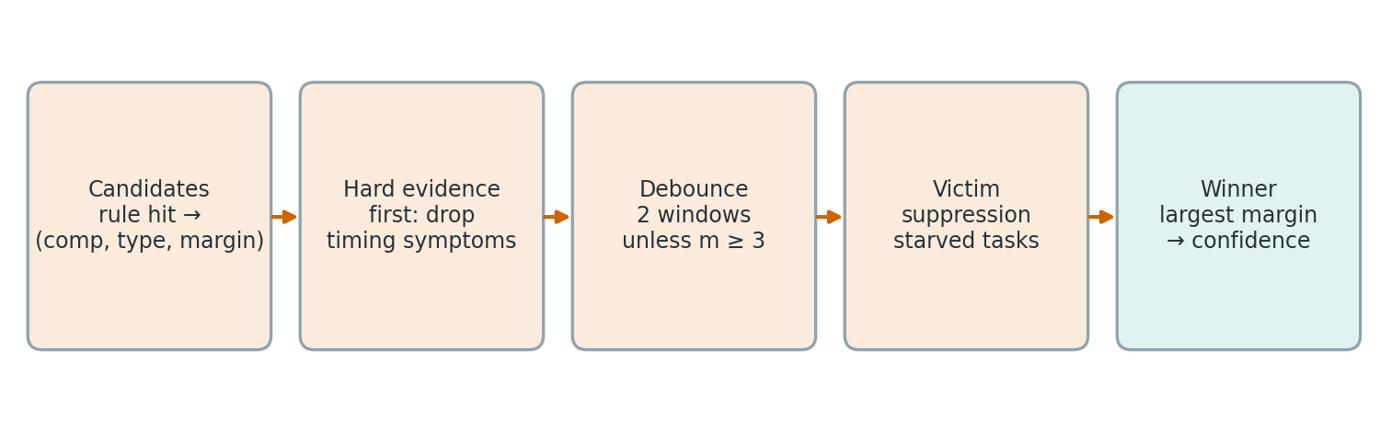
Figure 8.1: Localization pipeline from rule hits to the winning candidate

8.2 CONFIDENCE SCORING
The confidence score indicates the strength of the evidence supporting a detected fault. In the rule-based localizer, hard evidence is assigned a fixed confidence value, as shown in Table 8.1. For timing-based faults, the confidence is calculated using the logarithm of the margin (m), as given in Equation (8.1).
conf = 55 + 15 · log₂(m) (8.1)
A margin twice the threshold increases the confidence by 15 points, while a margin four times the threshold increases it by 30 points. If multiple candidates remain, 10 points are deducted for each additional candidate. The final confidence value is limited to a range of 30% to 99%.
For the statistical localizer, confidence is calculated using the anomaly score (S) and threshold (T), as shown in Equation (8.2).
conf = 100 · S / (S + T) (8.2)
A score equal to the threshold gives 50% confidence, while scores three and nine times the threshold give 75% and 90% confidence, respectively.
Table 8.1: Confidence assigned to each type of evidence
Evidence | Confidence
Stack-guard hit after reset | 99 %
Configuration CRC changed, peripheral error flag, memory trap | 95 %
Stage transition never seen, UART checksum error | 90 %
Watchdog reset with the last task known / unknown | 80 % / 40 %
Timing evidence (rule-based) | 55 + 15·log₂(m)
Statistical localizer | 100·S / (S + T)
Each additional surviving candidate | −10 %

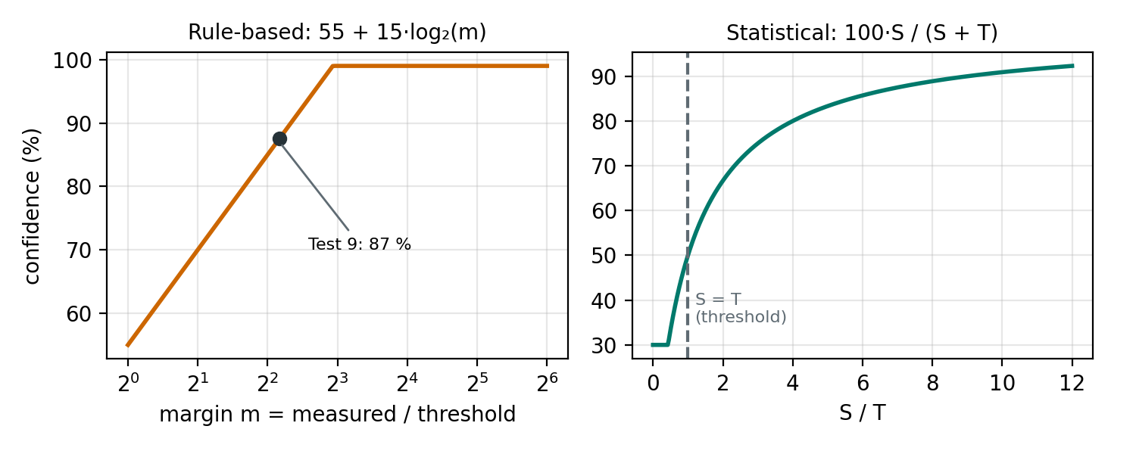
Figure 8.2: Confidence as a function of the margin (rule-based) and of S/T (statistical)
As a worked example, the missed-deadline test of Chapter 12 left the sensor task silent for 100 ms against a liveness limit of 22 ms, a margin of about 4.5. The formula gives 55 + 15 × log₂(4.5) ≈ 87 %, which is exactly the confidence reported by the board.

8.3 RECOVERY ENGINE
Recovery is table-driven and deterministic (Table 8.2). Task faults restart the task through its registered restart function, which deletes and recreates it. Peripheral and interrupt faults pulse the peripheral's reset line in RCC and reconfigure it exactly as at boot. Memory traps and watchdog resets are logged only, because the reset has already happened. If the same component fails again within 10 s, the simple fix evidently did not hold, so the engine escalates (Figure 8.3).
Table 8.2: Recovery table
Fault class | Action
Task (overrun, liveness, sequence, stack) | RESTART_TASK
Peripheral, interrupt, communication | REINIT_PERIPH: RCC reset and reconfiguration
Trap, watchdog | Reported after the reset
Same component again within 10 s | Level 1: also re-initialise all peripherals; level 2: system reset

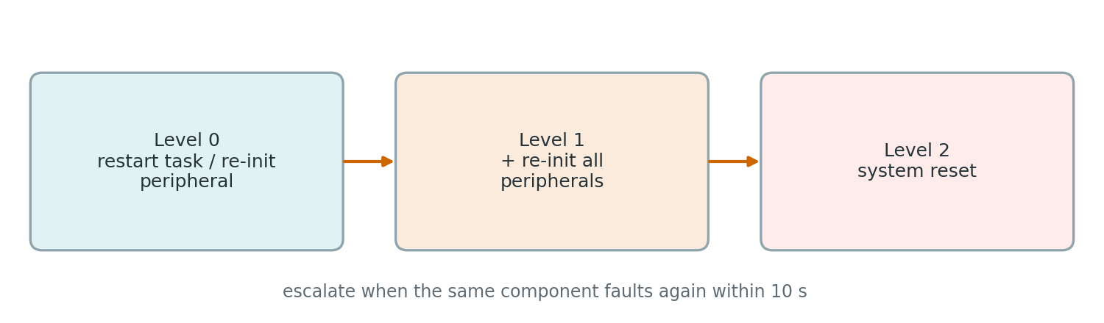
Figure 8.3: Escalation of recovery for repeated faults on the same component

8.4 WATCHDOG DESIGN
The independent watchdog uses a 32 kHz Low-Speed Internal (LSI) oscillator, which operates independently of the main system clock. With a prescaler of 64 and a reload value of 2000, the watchdog resets the microcontroller after approximately 4 seconds if it is not refreshed.
The watchdog feeder task runs at the highest priority and refreshes the watchdog every 250 ms, but only if the monitor task has checked in within the last 1.5 seconds. If the monitor stops responding, the watchdog triggers a system reset. This protects the system against both application failures and monitor failures. During debugging, the watchdog is frozen when the processor is halted. Therefore, watchdog testing must be performed without an external debugger connected.

8.5 FAULT REPORT AND FLASH BLACK BOX
Whenever a fault is detected, the framework generates a 164-byte fault report. The report is transmitted through UART as a !FAULT message, followed by !HIST messages containing recent execution history.
The reports are also stored in flash memory sector 7, which can hold up to 512 reports. The sector is erased only when it becomes full, allowing previous fault records to remain available even after power loss or firmware reflashing.
If a fault causes the processor to stop, the trap handler or watchdog first stores the available fault information in .noinit memory. During the next boot, the monitor retrieves this information and generates the corresponding fault report in flash memory.
Table 8.3: Contents of a fault report
Field | Meaning
seq, type, comp | What happened and where
conf, loc | How sure, and which localizer decided
action, rules | What was done and which rules fired
pc, cfsr, addr | Faulting instruction and fault registers (traps)
reset cause, uptime | Context
16 × event_t | Execution history before the fault, with relative timestamps

CHAPTER 9
FAULT INJECTION FRAMEWORK

9.1 PROPOSED ARCHITECTURE
Real firmware faults are difficult to reproduce and evaluate because they occur rarely and unpredictably. Therefore, deliberate fault injection is used to test the monitoring framework.
The fault injector is implemented in software and controlled through the command shell using the command I fault component delay. Before injecting a fault, the requested command is checked against a predefined table of valid fault types and target components. The validated request is then stored in a small record while interrupts are briefly disabled.
Task-related faults are triggered inside the target task when it reaches its injection point. These faults execute using the target task's own stack. Hardware-related faults are triggered through the 1 kHz TIM6 interrupt. Whenever a fault occurs, an INJECT event is recorded in the trace, and the details are stored in RAM and .noinit memory.
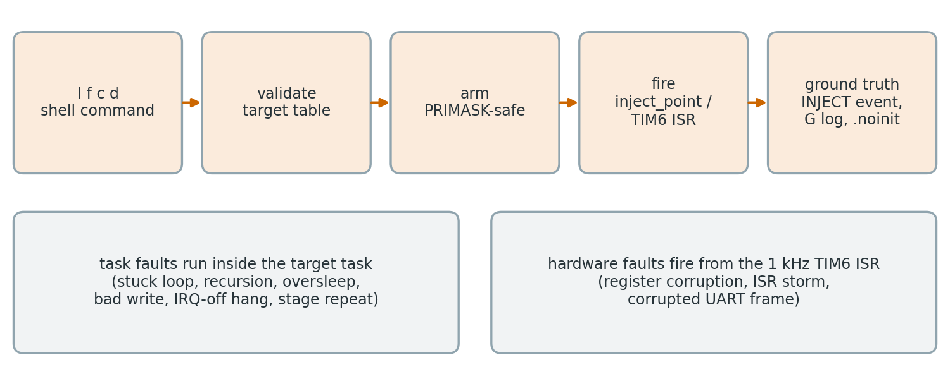
Figure 9.1: Path of a fault from the command to the ground-truth record
The monitoring framework does not receive information about the injected fault. It identifies the fault only by observing its effects on system behaviour. After localization, the actual injected fault is compared with the identified component using a !GT message. The G command displays the ground-truth log, which records when a fault is scheduled and when it occurs. The X command cancels a fault that has not yet been triggered.

9.2 FAULT CATALOGUE
The project uses ten different fault types to test the eight monitored signals, as listed in Table 9.1. Each fault type is restricted to specific components where that fault can occur meaningfully. The I command displays the valid component identifiers for each fault type. If an invalid target is selected, the command is rejected, and the shell displays the list of valid targets.
Table 9.1: Injectable faults
ID | Fault | Mechanism | Valid targets | Expected detection
1 | STUCK_LOOP | Infinite loop with interrupts enabled | 0, 1, 2 | EXEC_OVERRUN
2 | STACK_OVERFLOW | Unbounded recursion into the MPU guard | 0, 1, 2 | STACK_OVERFLOW
3 | MISSED_DEADLINE | Task sleeps 10 × its period | 0, 1 | LIVENESS
4 | ISR_STORM | TIM6 from 1 kHz to 10 kHz with extra work | 6 | ISR_RATE
5 | MEM_RO_WRITE | Write to the MPU read-only block | 0, 1, 2 | MEM_ACCESS
6 | NULL_DEREF | Write to address 0x10 | 0, 1, 2 | MEM_ACCESS
7 | PERIPH_CORRUPT | Overwrite one configuration register | 9–12 | PERIPH
8 | UART_CORRUPT | Frame with a wrong checksum into the receive path | 12 | COMM
9 | WDG_HANG | Interrupts disabled, endless loop | 0, 1, 2 | WATCHDOG
10 | SEQ_REPEAT | Stage C executed three times | 0 | SEQUENCE

9.3 TASK FAULTS
Task faults are designed so that the compiler cannot remove them and they reliably trigger the protection mechanisms. For example, the stack-overflow fault uses a 64-byte volatile array at every recursion level and accesses it after the recursive call. This prevents tail-call optimisation, which could otherwise reuse the same stack frame and avoid overflow. Since each 64-byte frame is larger than the 32-byte stack guard, the guard cannot be skipped.
Listing 9.1: Stack-overflow and hang faults
static uint32_t do_stack_overflow(uint32_t d)
{
volatile uint8_t eat[64]; // 64 B per level
for (uint32_t i = 0; i < 64; i++) eat[i] = (uint8_t)d;
s_sink = do_stack_overflow(d + 1) + eat[0]; // no tail call
return s_sink;
}
case FAULT_STUCK_LOOP: for (;;) { __NOP(); } // IRQs stay on
case FAULT_WDG_HANG: __disable_irq(); for (;;) { __NOP(); }

The stuck-loop fault keeps interrupts enabled, causing only the target task to hang. The higher-priority monitor task can still run. In contrast, the watchdog-hang fault disables all interrupts, preventing all tasks, including the monitor, from running. Recovery is therefore possible only through the independent watchdog.

9.4 HARDWARE FAULTS
Hardware faults modify actual peripheral registers from the TIM6 interrupt. These include the ADC1 trigger-selection bits, the TIM2 prescaler (which makes sampling approximately nine times faster), the PA0 mode bits, and the USART2 sampling mode. The interrupt-storm fault changes the TIM6 prescaler to generate interrupts at 10 kHz and adds extra processing to each interrupt.
The UART fault inserts the frame $T 55*00 into the receive queue as if it had arrived through the UART. This frame requests an alarm limit of 55 mV but contains an incorrect checksum; the correct checksum is 13.
The W command writes a specified value to any memory address. It was used to corrupt a register without using the fault injector, so the monitor had no injection record for this fault.

Listing 9.2: Register corruption from the TIM6 interrupt
void app_corrupt_periph(uint8_t comp) {
switch (comp) {
case COMP_PER_ADC: ADC1->CR2 ^= 1U << ADC_CR2_EXTSEL_Pos; break;
case COMP_PER_TIM: TIM2->PSC = 8U; break;
case COMP_PER_GPIO: GPIOA->MODER &= ~(3U << 0); break;
case COMP_PER_UART: USART2->CR3 |= USART_CR3_ONEBIT; break;
}
}

CHAPTER 10
REAL-TIME CLOCK
During the initial tests, it was observed that fault detection and recovery usually take only 0.1 to 0.3 seconds. Although this quick recovery is beneficial, it makes the actual impact of each fault difficult to observe. By the time the LED or telemetry output is checked, the system has usually returned to normal operation. To measure the effect of each fault on the application, a real-time clock add-on was developed.

10.1 DESIGN
The clock measures application time by counting the 10 ms sample blocks received through DMA. It uses the block sequence counter already maintained by the ADC interrupt and compares this time with the independent FreeRTOS system tick. As shown in Figure 10.1, it reports two values:
Drift: The difference between the clock time and the reference time. Negative drift indicates lost samples, while positive drift indicates that samples are arriving faster than expected.
Missed deadlines: The number of 10 ms periods during which the clock task could not run because a higher-priority task was using the CPU.
A heartbeat LED connected to PA6 (D12) toggles every 0.5 seconds. It therefore blinks at 1 Hz during normal operation and stops when the system freezes.
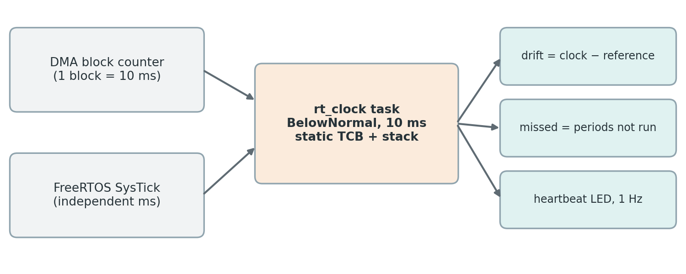
Figure 10.1: Inputs and outputs of the real-time clock add-on
The clock prints a status line every second. For example: CLK 00:01:23 | ref 00:01:23 | drift +0 ms | missed 0. It also prints an immediate CLK! message when a deadline is missed or when the drift changes by 30 ms or more. Under normal conditions, the expected timing variation is approximately ±1 sample block. The Z command displays the clock status, while Z R resets the drift and missed-deadline counters before each test.
The add-on was implemented in a single source file. It starts automatically through a GCC constructor, which is placed in the .init_array section and called by the startup code before main(). The clock task uses a statically allocated task control block and stack, so it does not consume memory from the FreeRTOS heap used by the other tasks. It runs at BelowNormal priority and is not registered as a monitored component. Faults cannot target this task; it only observes their effects. Its variables are also kept out of the .data section to prevent changes to the address of the MPU-protected configuration block.

CHAPTER 11
TESTING METHODOLOGY
All the testing activities were carried out using the STM32 NUCLEO-F446RE development board running the FreeRTOS-based fault-monitoring application. The sensor input pin (PA0) was connected to GND to provide a stable input condition during testing, except for tests that required a different input. A heartbeat LED was connected to pin D12 through a 330 Ω current-limiting resistor. This LED was used to observe the normal operation of the application and to check whether the system continued running after a fault was detected and recovered.
The board was connected to a computer through the ST-LINK Virtual COM Port (VCP) for sending commands and monitoring system responses. The UART communication was configured with a baud rate of 115200, 8 data bits, no parity, and 1 stop bit. A serial terminal was used to communicate with the board, inject different types of faults, and observe the responses generated by the monitoring system.
For proper documentation and analysis, the output of every test was saved in a separate log file. These logs contained information about the injected faults, detection messages, localization results, recovery actions, and system timing information. Keeping separate log files makes it easier to compare the results and verify the performance of the fault-monitoring framework.
Most of the tests were performed without an active debugger session. This was important because the debugger can pause the processor when a fault exception occurs and may also freeze the watchdog timer. Such behavior could affect the actual execution of the firmware and produce results that differ from normal standalone operation. Therefore, running the board without a debugger helped verify that the monitoring and recovery mechanisms worked independently using only the microcontroller's internal resources.

11.1 PROCEDURE
A common testing procedure was followed for every fault injection to maintain consistency and ensure that the results could be compared reliably. Before starting each test, the serial terminal was cleared to avoid confusion with the output from previous tests. The clock resynchronization command (Z R) was entered first to resynchronize the real-time clock add-on. After synchronization, the required fault command was sent through the UART interface to introduce the selected fault into the application. The monitoring system then observed the system behaviour, detected any abnormal condition, identified the possible source of the fault, and performed the required recovery action.
Once the detection and recovery process was completed, the R command was used to display the stored fault log, while the Z command was used to check the clock status. The complete terminal output was then saved as a separate log file for further analysis and verification. A minimum interval of 11 seconds was maintained between two fault injections affecting the same component. This delay was necessary to allow the monitoring system to complete its detection and recovery process before another fault was introduced. It also prevented the fault escalation mechanism from treating two closely spaced faults as a single continuous failure. Tests that could cause a complete system reset were performed at the end to avoid interrupting the remaining test activities.
Each fault test was considered successful only when all four verification conditions were
satisfied:
- 1. Fault Injection: The injected fault had to be confirmed through the !GT message or the G log entry. This verified that the intended fault was introduced into the correct component.
- 2. Fault Detection: The monitoring system had to identify the abnormal condition and generate a !FAULT message. This confirmed that the fault-monitoring mechanism had successfully detected the problem.
- 3. Fault Localization: The !GT message had to display the status LOCALIZED CORRECTLY. This verified that the system had identified the actual faulty component rather than simply detecting an abnormal condition.
- 4. Fault Recovery: The system had to report the expected recovery action, such as restarting the affected task, reinitializing a peripheral, or resetting the microcontroller. The application was also required to continue operating after recovery, wherever the selected recovery action allowed it.

By following these four conditions, each test was evaluated not only on whether the fault was detected, but also on whether the system could correctly identify its source and recover from it. This provided a more complete assessment of the proposed autonomous firmware fault-localization framework.

11.2 TEST CASES
Table 11.1: Test cases of the campaign
Test | Purpose | Input
1 | Boot and system health | Reset, Y 0, Z
2 | Baseline learning | C, L 100, B
3 | Clean run, false-alarm check | Z R, 2 minutes, Z, S
4 | Application input | PA0 GND → 3.3 V → GND
5 | Stuck task | I 1 0
6 | ADC1 trigger corrupted | I 7 9 1000
7 | TIM2 prescaler corrupted | I 7 10 1000
8 | Register write without injector | W 40000028 8
9 | Missed deadline | I 3 0 1000
10 | Wrong execution sequence | I 10 0 1000
11 | Interrupt storm | I 4 6 1000
12 | Corrupted command frame | I 8 12 1000
13 | Write to protected memory | I 5 0 1000
14 | Stack overflow | I 2 0 1000
15 | Total hang, watchdog reset | PA0 3.3 V, I 9 0 1000, PA0 to GND
16 | Rule-based vs statistical localizer | M 1, I 1 0 1000, M 0
17 | Cancelling a pending fault | I 1 0 5000, X
18 | Fault-log readback | R, R 16, G, S, D

CHAPTER 12
RESULTS
This chapter presents the serial output recorded on the NUCLEO-F446RE for each test cases. The excerpts are taken from the log files saved during testing. Only repeated clock lines before and after the relevant part have been left out.

12.1 TEST 1: BOOT AND SYSTEM HEALTH
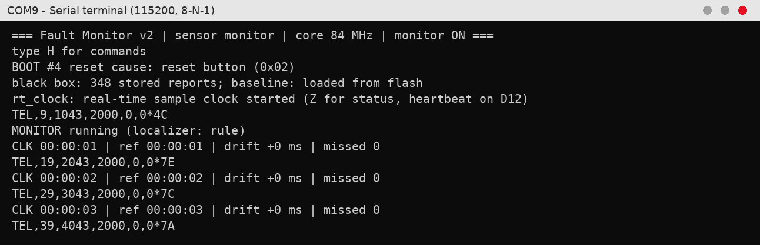
Figure 12.1: Serial output of Test 1
After the reset the firmware reported the cause of the restart (reset button, flag 0x02), loaded the stored baseline and fault log from flash and started the real-time clock. Monitoring began after the one-second warm-up. The telemetry frames arrive exactly 1000 ms apart (1043, 2043, 3043 ms) with the input at 0 mV, and the clock lines show zero drift and no missed deadlines. The system is healthy before any fault is injected.

12.2 TEST 2: BASELINE LEARNING
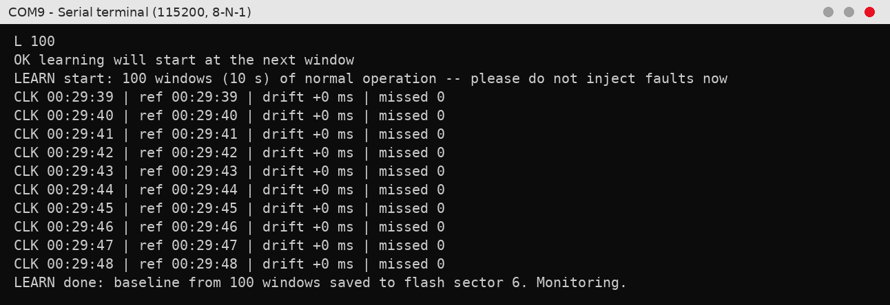
Figure 12.2: Serial output of Test 2 (a)
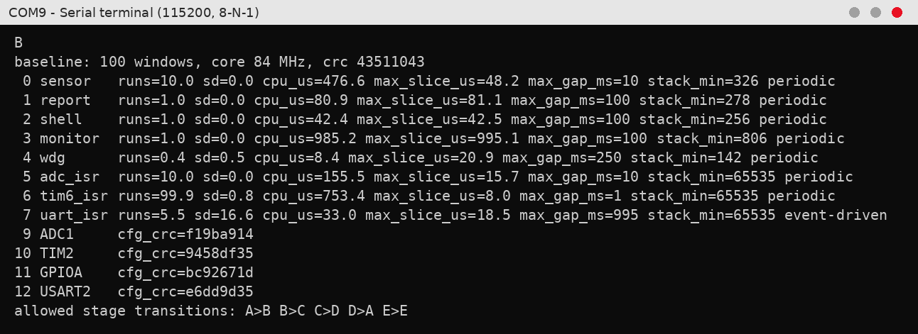
Figure 12.3: Serial output of Test 2 (b)

Learning started at a window boundary and finished exactly 10 s later, after 100 windows of 100 ms, and the baseline was saved to flash sector 6. The B command shows what was learned: the sensor task runs 10 times per window with zero variation and about 48 µs per run, the ADC interrupt runs 10 times at under 16 µs, and the 1 kHz timer interrupt about 100 times. The configuration checksums of ADC1, TIM2, GPIOA and USART2 were recorded, and the allowed stage order is A>B>C>D. The monitor itself needs about 1 ms per window, roughly 1 % of the CPU.

12.3 TEST 3: CLEAN RUN (FALSE-ALARM CHECK)
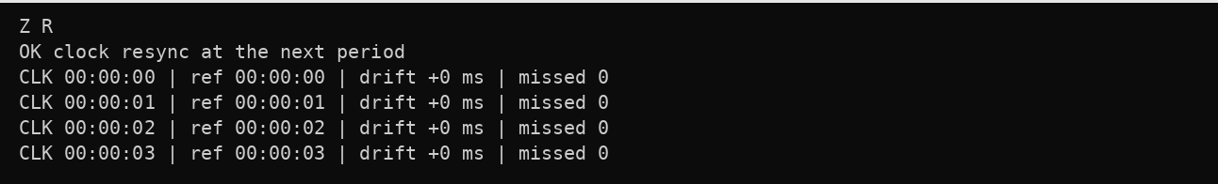
Figure 12.4: Serial output of Test 3 (a)
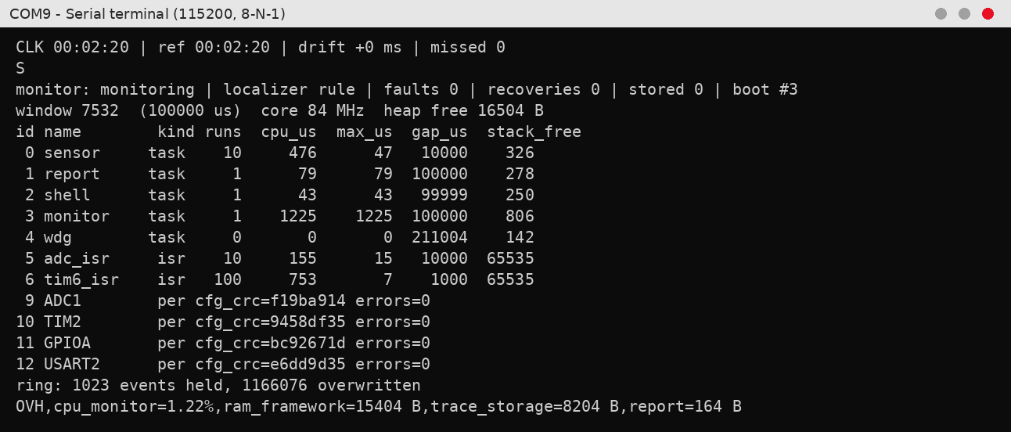
Figure 12.5: Serial output of Test 3 (b)
After the clock was resynchronised, the board was left running for 2 minutes 20 seconds, about 1 300 monitoring windows, without any input. No fault was reported and the clock stayed at zero drift. The status output shows faults 0 and recoveries 0, the live timing of every component matches the baseline, and all four peripheral checksums are unchanged. The overhead line gives the measured cost of the monitor: 1.22 % of the CPU, 15 404 bytes of RAM for the framework and 8 204 bytes for the trace buffer.

12.4 TEST 4: APPLICATION INPUT (PA0 AT GND AND 3.3 V)
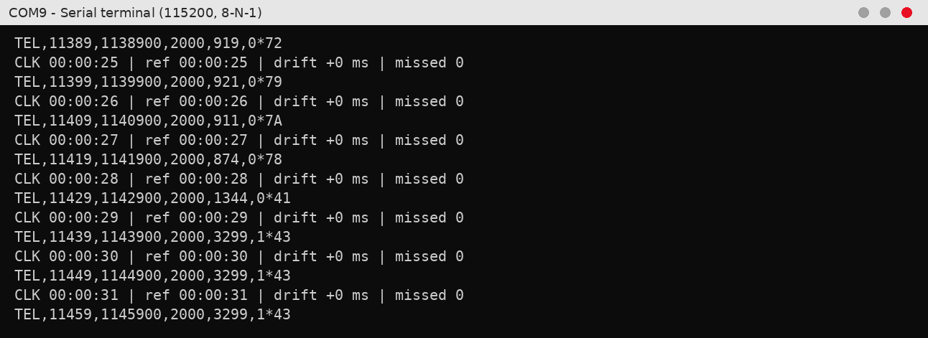
Figure 12.6: Serial output of Test 4 (a)
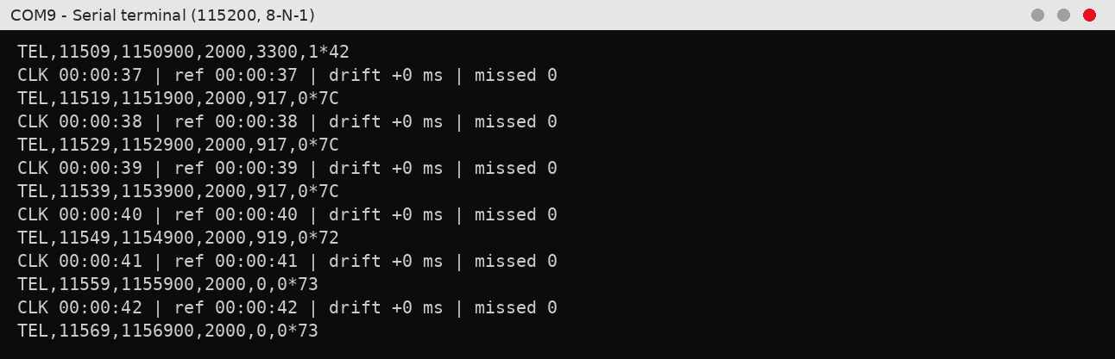
Figure 12.7: Serial output of Test 4 (b)
The fifth field of each TEL line is the measured input. While the wire was lifted the input floated at about 920 mV; connected to 3.3 V the reading rose through 1344 mV (the smoothing filter catching up) to 3299–3300 mV, above the 2000 mV limit, so the alarm field changed to 1 and LED LD2 switched on. Back at GND the reading fell to 0 mV and the alarm switched off. No fault was reported at any point and the clock kept zero drift, because a change of input is normal behaviour, not a firmware fault.

12.5 TEST 5: STUCK TASK
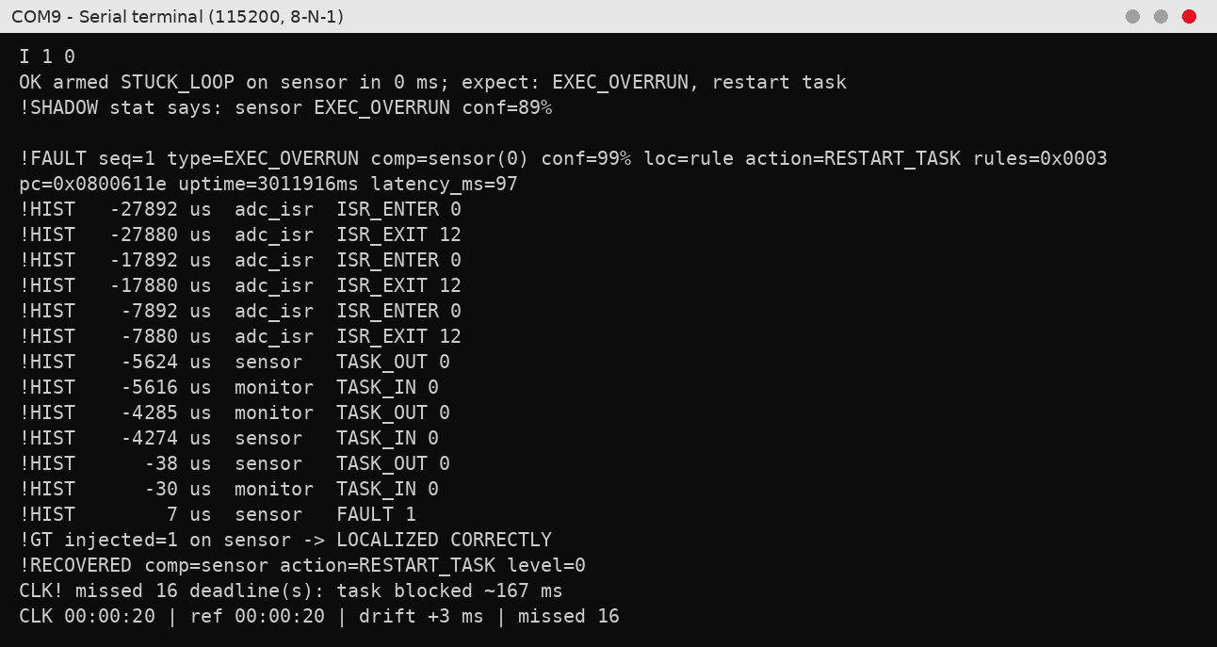
Figure 12.8: Serial output of Test 5
An infinite loop was injected into the sensor task. The history shows the ADC interrupt still arriving every 10 ms, while the sensor task, switched in at −4274 µs, never reaches its first processing stage. At the next 100 ms check, 97 ms after the fault, the monitor reported an execution overrun on the sensor task with 99 % confidence; the statistical localizer agreed at 89 %. The task was deleted and recreated without a reset. The real-time clock shows the damage to the application: it was blocked for 167 ms and missed 16 of its 10 ms deadlines.

12.6 TEST 6: ADC TRIGGER CORRUPTED
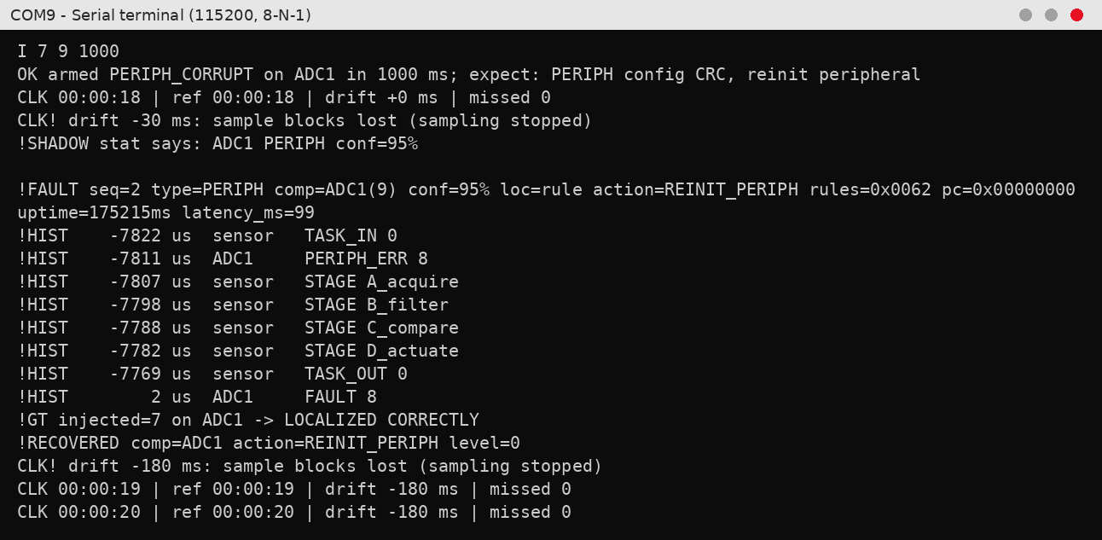
Figure 12.9: Serial output of Test 6
The trigger-selection bits of ADC1 were overwritten, so the converter stopped following its 1 kHz timer and sampling stopped. The sensor task logged a 50 ms timeout against ADC1 (PERIPH_ERR 8) and the clock reported the first missing samples. 99 ms after the fault the monitor blamed ADC1 with 95 % confidence: its configuration checksum no longer matched the baseline (rules 0x0062). ADC1 was reset and reconfigured. The clock settled at −180 ms and stayed there, which means 18 sample blocks were lost and sampling was fully restored.

12.7 TEST 7: SAMPLING TIMER CORRUPTED
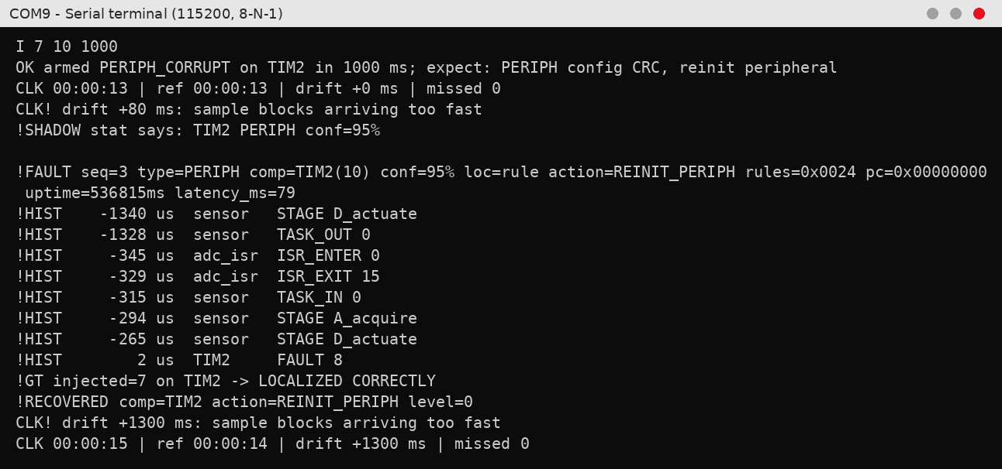
Figure 12.10: Serial output of Test 7
The prescaler of TIM2, the timer that triggers the ADC, was overwritten, so sampling ran about nine times too fast; the history shows complete pipeline cycles about 1 ms apart instead of 10 ms. The monitor blamed TIM2 with 95 % confidence after 79 ms. Two rules fired (0x0024): the changed TIM2 checksum, which is the cause, and the higher interrupt rate, which is only the symptom. TIM2 was restored to 1 kHz, and the clock ended 1.3 s ahead of real time, the timing error the application suffered.

12.8 TEST 8: REGISTER WRITE WITHOUT THE INJECTOR
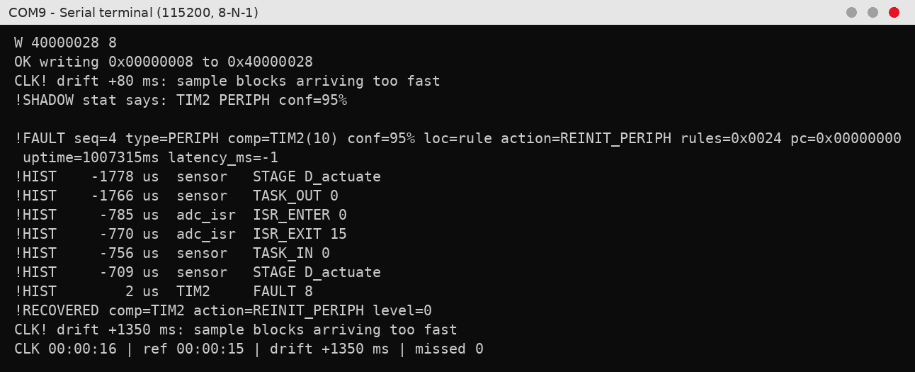
Figure 12.11: Serial output of Test 8
Here the TIM2 prescaler was written directly to address 0x40000028, without the fault injector, so the monitor had no injection record and no hint. It still detected the changed register and blamed TIM2 with 95 % confidence, then restored the timer. There is no !GT line and the latency is −1 because nothing was injected that could be compared or timed. The clock gained 1350 ms, almost the same as in the injected version, which shows that detection does not depend on how the fault was caused.

12.9 TEST 9: MISSED DEADLINE
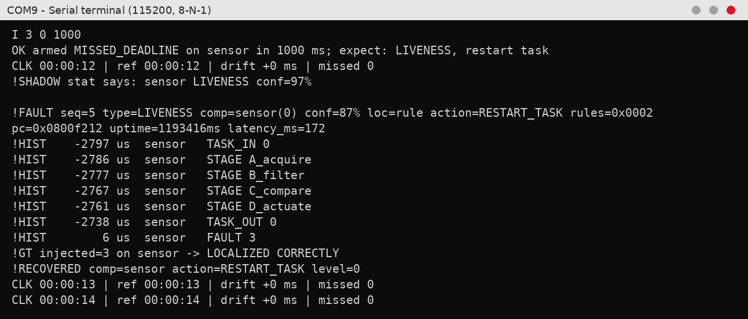
Figure 12.12: Serial output of Test 9
The sensor task was made to sleep for 100 ms instead of 10 ms. Its learned limit for silence is 22 ms (twice the normal 10 ms gap plus 2 ms), so a 100 ms gap is about 4.5 times over the limit, and the monitor reported a liveness fault on the sensor task with 87 % confidence (55 + 15·log₂4.5). The latency of 172 ms is the 100 ms of oversleeping plus the time to the next window check. The clock shows no change, because the hardware kept sampling and the CPU stayed free: this fault is visible only to the monitor.

12.10 TEST 10: WRONG EXECUTION SEQUENCE
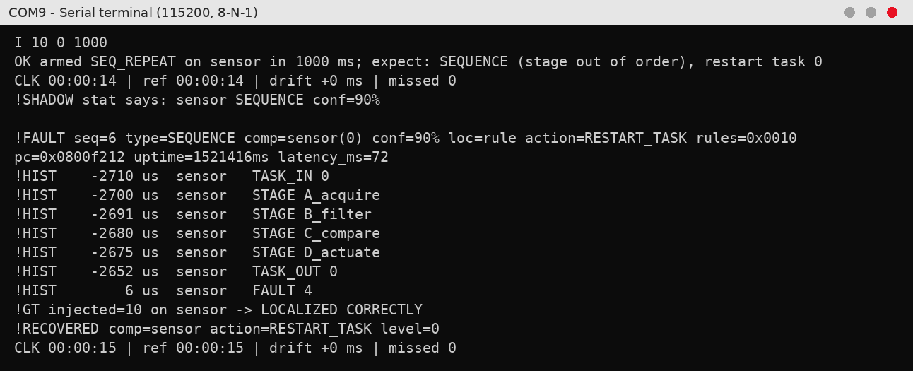
Figure 12.13: Serial output of Test 10
On one cycle the sensor pipeline executed its compare stage three times in a row (A→B→C→C→C→D). The transition C→C never appeared during learning, so the monitor treated it as hard evidence of a control-flow fault and reported it 72 ms later with 90 % confidence, then restarted the task. The repeated stages are no longer in the 16-event history because they happened earlier in the window; the history shows the next, normal cycle. The clock was unaffected: the fault was caught before it changed the application's timing or output.

12.11 TEST 11: INTERRUPT STORM
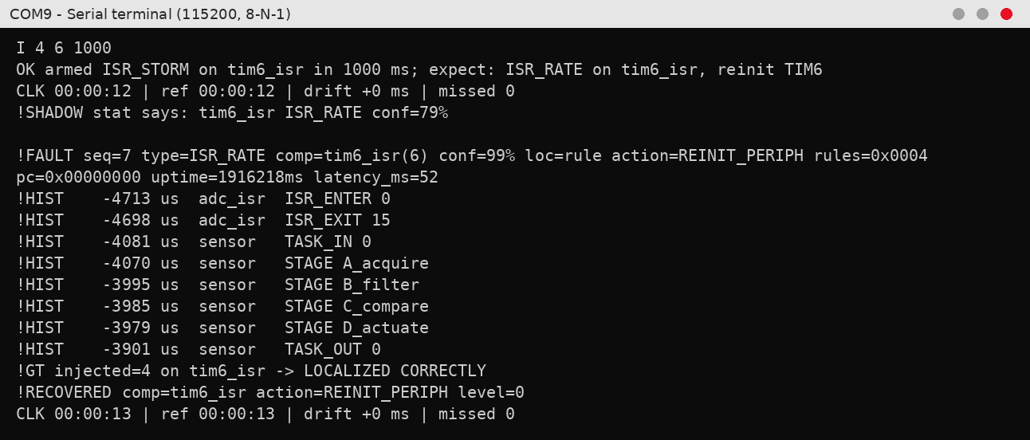
Figure 12.14: Serial output of Test 11
The TIM6 interrupt was switched from 1 kHz to 10 kHz with extra work in each interrupt. Its side effect is visible in the history: the sensor task's stages are stretched from about 10 µs to 75 µs apart because the interrupts keep preempting it. The monitor saw TIM6 firing far more often than the 99.9 ± 0.8 times per window it had learned and reported an interrupt-rate fault with 99 % confidence after only 52 ms. TIM6 was set back to 1 kHz and the clock showed no damage.

12.12 TEST 12: CORRUPTED COMMAND FRAME
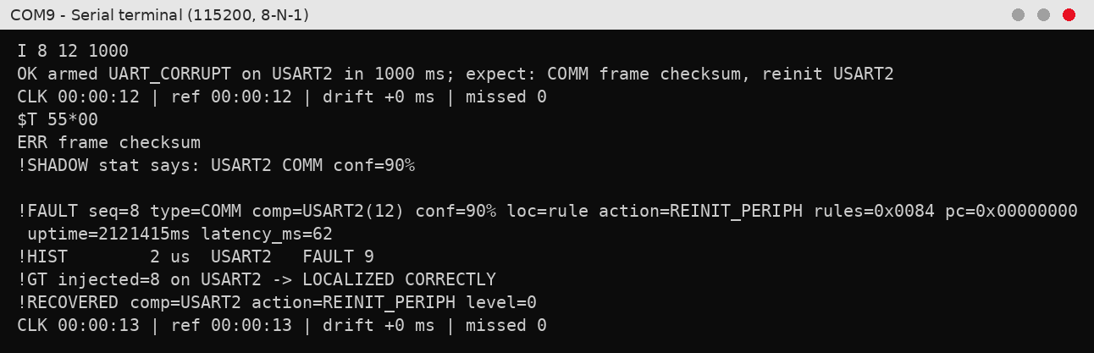
Figure 12.15: Serial output of Test 12 (a)
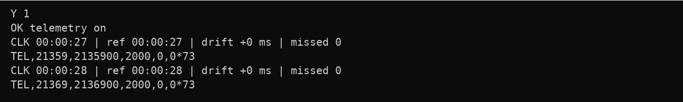
Figure 12.16: Serial output of Test 12 (b)
A command to set the alarm limit to 55 mV arrived with a wrong checksum, as if the serial line had been corrupted. The shell rejected it (ERR frame checksum), and the monitor reported a communication fault on USART2 with 90 % confidence after 62 ms and re-initialised the UART. The telemetry afterwards still shows the 2000 mV limit, so the corrupted command had no effect on the application.

12.13 TEST 13: WRITE TO PROTECTED MEMORY
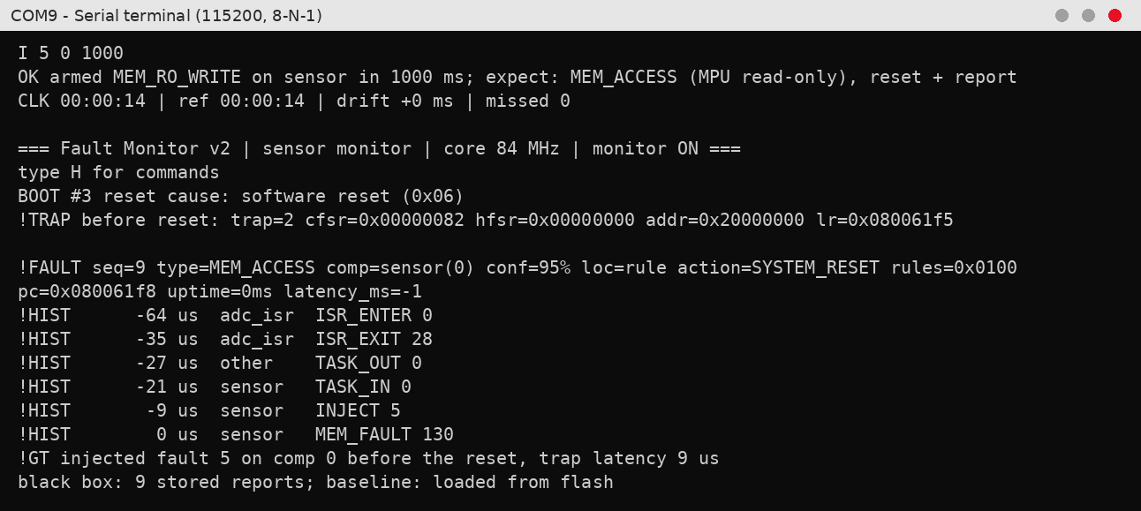
Figure 12.17: Serial output of Test 13
The fault tried to overwrite the application's configuration block, which the memory protection unit keeps read-only. The write was blocked by the hardware and raised a MemManage fault; the board saved a crash record and restarted itself (software reset). After the reboot the report shows CFSR 0x82, a data-access violation with a valid address, and the exact address 0x20000000 of the protected block. The fault was attributed to the sensor task with 95 % confidence and was trapped 9 µs after the faulty write. All earlier reports were still in flash.

12.14 TEST 14: STACK OVERFLOW
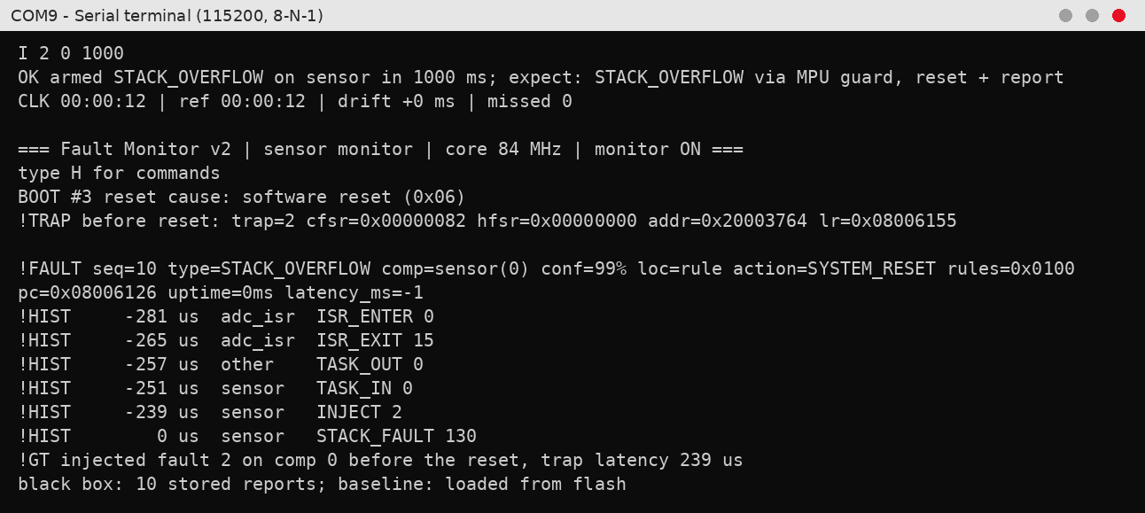
Figure 12.18: Serial output of Test 14
Unbounded recursion was started inside the sensor task, using 64 bytes of stack per call. After 239 µs the stack reached the 32-byte no-access guard below it, and the first write into the guard was stopped by the MPU before any other memory was corrupted. Because the faulting address 0x20003764 lies inside that guard, the fault was classified as a stack overflow with 99 % confidence. The board reset itself and the report was filed after the reboot.

12.15 TEST 15: TOTAL HANG AND WATCHDOG RESET
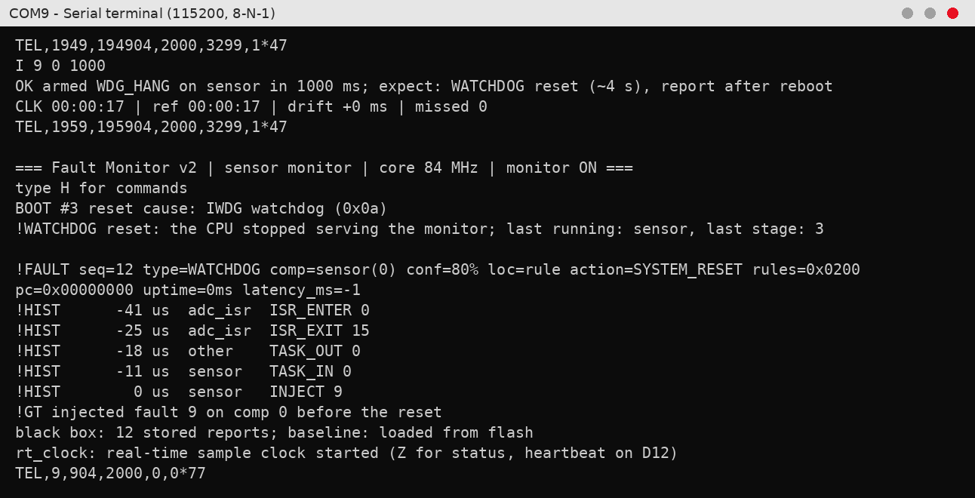
Figure 12.19: Serial output of Test 15
Before the fault the input was at 3.3 V and the alarm was on (3299 mV, alarm 1). The fault disabled all interrupts and looped forever, so nothing could run, not even the monitor, and the output stopped. The input was moved to 0 V during the freeze, but the frozen application could not switch the alarm off, and the heartbeat LED stopped. About 4 s later the independent watchdog reset the chip. After the reboot the reset cause read IWDG watchdog and the monitor named the sensor task, the task that was running when the system froze, with 80 % confidence. The first telemetry line shows 0 mV with the alarm off: the application was following its input again.

12.16 TEST 16: RULE-BASED VS STATISTICAL LOCALIZER
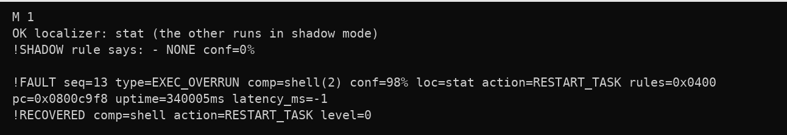
Figure 12.20: Serial output of Test 16 (a)
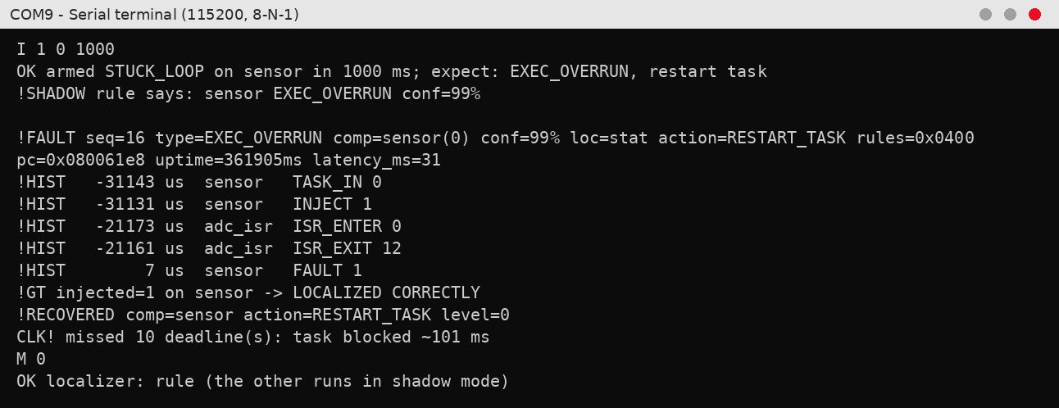
Figure 12.21: Serial output of Test 16 (b)
With the statistical localizer acting, the real stuck-task fault was found by both methods with 99 % confidence, 31 ms after injection. The statistical localizer, however, also raised false alarms on the command shell every time a command was typed (the first output), three in total, while the rule-based localizer reported nothing (NONE). During learning the shell showed almost no variation, so normal command handling looked like a large statistical deviation. The rule-based thresholds have absolute minimum values and are not affected, which is why the rule-based localizer is used by default.

12.17 TEST 17: CANCELLING A PENDING FAULT
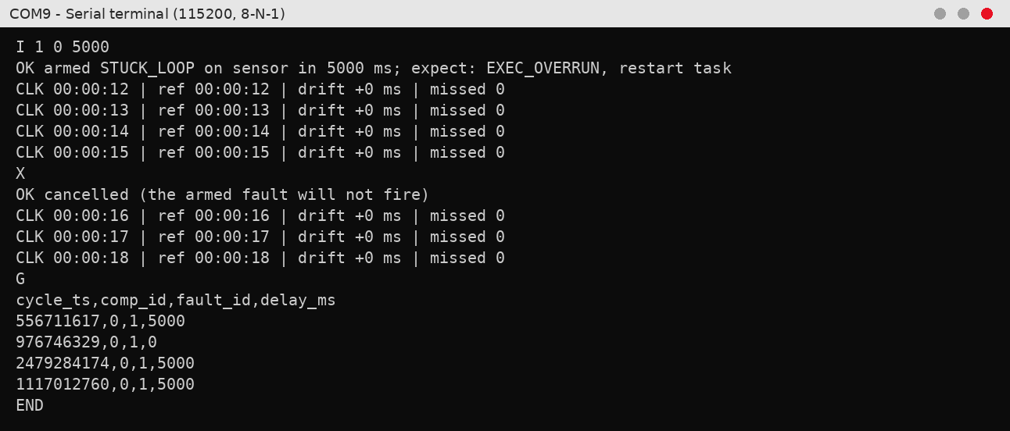
Figure 12.22: Serial output of Test 17
A stuck-loop fault was armed with a 5 s delay and cancelled about 4 s later. Nothing happened afterwards: no fault report and no change in the clock. The ground-truth log confirms it. Each fault writes one row when it is armed (delay 5000) and one when it fires (delay 0); the last row of this run has no fire row after it, so the fault never executed. The monitor reports only real misbehaviour, never the injection request itself.

12.18 TEST 18: FAULT LOG AFTER THE CAMPAIGN
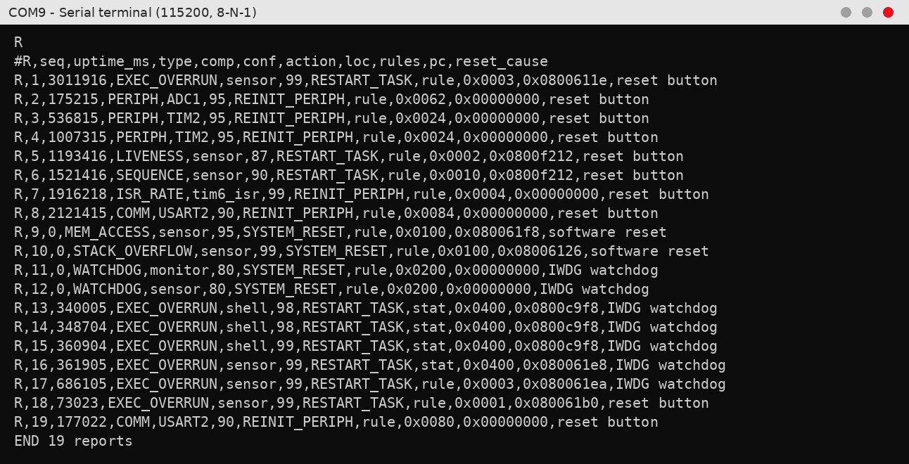
Figure 12.23: Serial output of Test 18
At the end of the campaign the fault log in flash still held all 19 reports, including those written before four fault resets and three reflashes of the firmware. Each line gives the fault type, the component, the confidence, the recovery action, the localizer, the rules that fired, the program counter and the reset cause of the boot in which it was read. Report 11 is the first watchdog run, recorded before a firmware fix (it named the monitor task); report 12 is the corrected repeat. Reports 13–15 are the statistical localizer's false alarms from Test 16, and report 19 is a genuine UART receive error that occurred during Test 17 without any injection.
After the reset the firmware reported the cause of the restart (reset button, flag 0x02), loaded the stored baseline and fault log from flash and started the real-time clock. Monitoring began after the one-second warm-up. The telemetry frames arrive exactly 1000 ms apart (1043, 2043, 3043 ms) with the input at 0 mV, and the clock lines show zero drift and no missed deadlines. The system is healthy before any fault is injected.

12.19 IMPACT ON THE APPLICATION
The clock add-on separates the faults into three groups. Faults 1, 7 on ADC1 and 7 on TIM2 damaged the application: it lost deadlines, lost samples or ran with the wrong timing. Faults that stopped the CPU (memory traps and the watchdog hang) cost the application its running state through the reset, and the hang caused a visible missed alarm. The remaining faults, the missed deadline, the sequence fault, the interrupt storm and the corrupted frame, were caught without any effect on the clock. For the missed deadline this means only that the clock could not see the damage; the monitor still detected it.

12.20 SUMMARY OF MEASURED RESULTS
Table 12.1: Key results of the test campaign
Metric | Value
Fault events detected | 15 of 15, including the raw register write
Localized correctly | 14 of 15 on the first attempt; the watchdog case after a fix and repeat
False alarms in the clean run | 0 in about 1 300 windows
False alarms over the whole campaign | Rule-based 1, statistical 3, all on the event-driven shell
Detection latency, runtime faults | 31–172 ms, median 72 ms
Detection latency, memory traps | 9 µs (protected write), 239 µs (stack overflow)
Monitor CPU overhead | 1.22–1.23 %
Framework RAM | 15 404 B, plus 8 204 B trace buffer
Report size | 164 B; 19 reports kept through 4 fault resets and 3 reflashes
Application cost | Sensor task 48 µs per 10 ms, ADC interrupt 15 µs; system about 97 % idle

CHAPTER 13
DISCUSSION

13.1 ANSWER TO THE RESEARCH QUESTION
The results support a qualified yes. Using only autonomous on-chip resources, the monitor detected every fault event in the campaign, named the right component in all but one case on the first attempt, recovered without a PC and left a report that explains what happened. The clean run produced no false alarms, and the cost was about 1.2 % of the CPU. The qualification is that the evaluation consists of one to two trials per fault class on one board, so the numbers demonstrate that the mechanisms work rather than giving statistically strong rates.

13.2 WHY HARD EVIDENCE MATTERS
The most reliable localizations came from binary evidence: a changed configuration checksum, a stage transition never seen in learning, an MPU violation with a known address. They gave 90 to 99 % confidence and never pointed to the wrong component. They were also the reason why symptoms did not mislead the monitor. When the ADC stopped, the sensor task went silent and could have been blamed for a missed deadline, but the checksum of ADC1 made the cause clear. The same happened with TIM2, where the faster interrupt rate was a symptom and the changed prescaler the cause.

13.3 TIMING EVIDENCE AND THE LOGARITHMIC SCORE
Timing evidence needs a good baseline and is graded rather than certain. The logarithmic confidence behaved as intended. A task that used about 200 times its normal CPU time was capped at 99 %, while a task silent for 4.5 times its limit received 87 %. Debouncing over two windows and victim suppression kept starved low-priority tasks from being blamed during the stuck-task fault.

13.4 RULE-BASED VERSUS STATISTICAL
On real faults the two localizers agreed. The difference appeared on an event-driven task. A statistical score measures distance in standard deviations, so a component that showed almost no variation during learning becomes very sensitive later. Absolute floors in the rule-based thresholds avoid this. For this system the rule-based localizer is the better default, and the statistical localizer would need a larger variance floor or a separate treatment of event-driven tasks.

13.5 COMPARISON WITH OTHER APPROACHES
Compared with offline techniques such as spectrum-based localization [11], [12] or post-fuzzing root-cause analysis [8], our monitor localizes at the level of components rather than statements, but it does so while the device runs and it acts on the result. Compared with a plain watchdog, which only resets, it names the component, distinguishes ten fault types, recovers most of them without a reset and keeps a history. The cost of these capabilities, about 1.2 % CPU and 23 KB of RAM including the trace buffer, is small on a microcontroller of this class.

CHAPTER 14
CHALLENGES AND LIMITATIONS

14.1 ISSUES FACED AND HOW THEY WERE RESOLVED
Several problems appeared while building and testing the system. Table 14.1 lists the main ones, their causes and the changes made.
Table 14.1: Issues faced during the project and their resolution
Issue observed | Root cause | Fix or mitigation
Some fault commands rejected with "invalid fault/target" | Each fault accepts only certain components, but the fault list did not show which | The fault list now prints the valid targets, and errors name them
History showed −51 130 562 µs for the trap event | A tiny positive cycle difference was converted as unsigned and wrapped to 2^32 cycles | Signed difference in the history printer; the event now shows 0 µs
Effects of faults invisible | Detection and recovery take 0.1–0.3s | Real-time clock add-on with drift, missed deadlines and heartbeat LED
Board froze at memory faults, watchdog never fired | A debug session halted the CPU at the fault handler and froze the watchdog | Autonomous tests run without a debugger session
Watchdog report blamed the monitor task | Last running task read after the new boot had overwritten it | Value captured before the scheduler starts; test repeated
Statistical localizer false alarms on the shell | Near-zero variance of the shell during learning | Rule-based localizer kept as default
Clock drift of +10 to +20 ms after learning | Flash writes stall the CPU and shift the block count by one block | Clock resynchronised before every test
Commands echoed but not executed | Terminal sent no line ending | Commands sent with Enter
Cancel reported success after the fault had fired | Message did not check whether a fault was pending | Message now reports the real state

14.2 LIMITATIONS
- Post-Reset Reporting: Memory faults and watchdog resets are reported only after the system restarts. A complete system hang cannot record the program counter or detection time.
- Event-Driven Tasks: The command shell produced one false alarm with the rule-based method and three with the statistical method.
- Limited Event History: Each report stores only the latest 16 events. Some earlier events may be missing, although the complete trace stores up to 1023 events.
- Execution-Based Detection: Incorrect data values that do not affect execution timing or behaviour cannot be detected.
- Limited Memory Protection: The MPU has eight regions, allowing a maximum of six stack guards. Full control-flow protection is not included.
- Debugger Interaction: Faults that cause system resets must be tested without an active debugging session.
- Limited Evaluation: Testing was performed on only one development board, using one application workload and one or two trials per fault type.

CHAPTER 15
CONCLUSION AND FUTURE SCOPE

15.1 CONCLUSION
This project focuses on the design, implementation, and evaluation of an autonomous runtime firmware fault-localization framework using execution signatures on an STM32F446RE microcontroller running FreeRTOS. The primary objective is to identify abnormal firmware behaviour, localize potential faults, and initiate appropriate recovery actions without depending on external debugging equipment or continuous PC connectivity. The framework uses the hardware monitoring capabilities available within the ARM Cortex- M4 processor to observe firmware execution and analyse deviations from normal operating behaviour.
The framework captures eight categories of runtime information using on-chip hardware resources and lightweight software mechanisms. These include task switches, interrupt entries and exits, application stage transitions, peripheral errors, communication errors, execution timing information, memory-related faults, and watchdog events. The Data Watchpoint and Trace (DWT) cycle counter provides high-resolution execution timestamps, while FreeRTOS trace hooks collect task-level execution events. These events are stored in an 8 KB circular buffer to maintain a recent history of system execution without requiring large amounts of memory. Additionally, Memory Protection Unit (MPU) guards, processor fault status registers, peripheral configuration checksums, error flags, and the reset-cause register are used to identify different abnormal conditions. An independent watchdog provides additional protection against situations in which normal system execution cannot be maintained.
The framework generates a runtime execution signature at regular 100 ms intervals. During fault-free operation, the system learns a reference baseline representing the normal execution characteristics of the application. This baseline is retained on the target board so that subsequent execution behaviour can be compared against the learned reference, including after system resets. During normal operation, the monitor continuously evaluates task execution periods, execution durations, interrupt activity, application stage sequences, and peripheral status. Any significant deviation from the expected behaviour is analysed using predefined diagnostic rules to identify the potentially affected task, interrupt, or peripheral. A confidence score is assigned to indicate the likelihood that the identified component is associated with the detected abnormality.
When a fault is detected, the framework generates a diagnostic report containing the fault type, suspected component, confidence score, triggered diagnostic rules, program counter information where available, and the most recent 16 execution events. Recovery is performed using a predefined deterministic recovery table. If the same component experiences another failure within a 10-second interval, the framework escalates the recovery response. Fault reports are stored in flash memory for later retrieval, allowing diagnostic information to remain available even after a system reset. A command-line interface is also provided to inject and cancel faults, retrieve ground-truth information, inspect execution traces, and monitor the overall system status during testing.
The framework was evaluated using a soft real-time sensor application with ten injectable fault types. A real-time clock add-on was incorporated to measure the time associated with fault occurrence, detection, localization, and recovery. An 18-case experimental campaign was conducted on the STM32F446RE development board to assess the detection accuracy, localization capability, response time, and monitoring overhead. Out of the 18 test cases, all 15 fault events were detected, including two events that were not successfully generated by the fault injector. Fourteen cases were localized correctly on the first attempt, while the remaining case helped identify an implementation issue that was subsequently corrected and verified through repeated testing.
The measured runtime fault-reporting latency ranged from 31 to 172 ms, while memory-protection faults were trapped within 9 to 239 µs. No false alarms were observed during the clean-operation test, indicating that the monitoring mechanism could distinguish normal execution behaviour from the tested abnormal conditions. Furthermore, the monitor consumed approximately 1.2% of the available CPU processing capacity, demonstrating that continuous execution monitoring can be implemented with relatively low computational overhead.
Overall, the experimental results demonstrate that runtime execution signatures can provide a practical approach to autonomous firmware fault detection and localization on resource-constrained microcontrollers. The framework combines hardware-based execution monitoring, task-level behavioural analysis, confidence-based fault localization, deterministic recovery, and persistent diagnostic reporting within a single embedded platform. Its ability to operate directly on the target microcontroller without requiring external trace hardware makes it a useful approach for improving the dependability, maintainability, and diagnostic capabilities of real-time embedded systems.

15.2 FUTURE SCOPE
- Conduct 15–20 repeated tests for each fault type to obtain more reliable detection and false-alarm results.
- Improve the detection rules by increasing the variance limit or using separate rules for event-driven tasks to reduce false alarms.
- Compare the existing method with an Isolation Forest machine-learning model trained using recorded execution signatures.
- Test the framework on other Cortex-M microcontrollers, including those without an MPU, to identify the available monitoring features.
- Add application-level checks to detect incorrect data values that do not affect program execution.
- Test shorter monitoring intervals for applications with tighter timing requirements and measure their effect on detection speed and CPU usage.

REFERENCES
[1]A. Avizienis, J.-C. Laprie, B. Randell and C. Landwehr, "Basic concepts and taxonomy of dependable and secure computing," IEEE Transactions on Dependable and Secure Computing, vol. 1, no. 1, pp. 11–33, Jan.–Mar. 2004.
[2] International Electrotechnical Commission, "IEC 61508: Functional safety of electrical/electronic/programmable electronic safety-related systems," 2nd ed., Geneva, 2010.
[3]International Organization for Standardization, "ISO 26262: Road vehicles – Functional safety," 2nd ed., Geneva, 2018.
[4] ARM Ltd., "ARMv7-M Architecture Reference Manual," ARM DDI 0403E, 2014.
[5]J. Yiu, The Definitive Guide to ARM Cortex-M3 and Cortex-M4 Processors, 3rd ed. Oxford, U.K.: Newnes, 2014.
[6] STMicroelectronics, "RM0390 Reference manual: STM32F446xx advanced Arm-based 32-bit MCUs," Rev. 6, 2021.
[7]W. E. Wong, R. Gao, Y. Li, R. Abreu and F. Wotawa, "A survey on software fault localization," IEEE Transactions on Software Engineering, vol. 42, no. 8, pp. 707–740, Aug. 2016.
[8]B. Chang et al., "FirmRCA: Towards post-fuzzing analysis on ARM embedded firmware with efficient event-based fault localization," in Proc. IEEE Symposium on Security and Privacy (SP), 2025.
[9] A. Mahmood and E. J. McCluskey, "Concurrent error detection using watchdog processors – a survey," IEEE Transactions on Computers, vol. 37, no. 2, pp. 160–174, Feb. 1988.
[10] N. Oh, P. P. Shirvani and E. J. McCluskey, "Control-flow checking by software signatures," IEEE Transactions on Reliability, vol. 51, no. 1, pp. 111–122, Mar. 2002.
[11]J. A. Jones, M. J. Harrold and J. Stasko, "Visualization of test information to assist fault localization," in Proc. 24th International Conference on Software Engineering (ICSE), 2002, pp. 467–477.
[12]R. Abreu, P. Zoeteweij and A. J. C. van Gemund, "On the accuracy of spectrum-based fault localization," in Proc. Testing: Academic and Industrial Conference – Practice and Research Techniques (TAICPART-MUTATION), 2007, pp. 89–98.
[13]U. T. Gabor, "Software fault injection and localization in embedded systems," Ph.D. dissertation, Technische Universität Dortmund, Dortmund, Germany, 2021.
[14] ARM Ltd., "Cortex-M4 Technical Reference Manual," ARM DDI 0439B, 2010.
[15]M.-C. Hsueh, T. K. Tsai and R. K. Iyer, "Fault injection techniques and tools," Computer, vol. 30, no. 4, pp. 75–82, Apr. 1997.
[16]H. Ziade, R. Ayoubi and R. Velazco, "A survey on fault injection techniques," The International Arab Journal of Information Technology, vol. 1, no. 2, pp. 171–186, Jul. 2004.
[17] A. Benso and P. Prinetto, Eds., Fault Injection Techniques and Tools for Embedded Systems Reliability Evaluation. Boston, MA, USA: Kluwer Academic, 2003.
[18]Y. Li, S. Makar and S. Mitra, "CASP: Concurrent autonomous chip self-test using stored test patterns," in Proc. Design, Automation and Test in Europe (DATE), 2008, pp. 885– 890.
[19]V. Chandola, A. Banerjee and V. Kumar, "Anomaly detection: A survey," ACM Computing Surveys, vol. 41, no. 3, pp. 15:1–15:58, Jul. 2009.
[20]F. T. Liu, K. M. Ting and Z.-H. Zhou, "Isolation forest," in Proc. 8th IEEE International Conference on Data Mining (ICDM), 2008, pp. 413–422.
[21]B. P. Welford, "Note on a method for calculating corrected sums of squares and products," Technometrics, vol. 4, no. 3, pp. 419–420, Aug. 1962.
[22]R. Barry, Mastering the FreeRTOS Real Time Kernel: A Hands-On Tutorial Guide. Real Time Engineers Ltd., 2016.

